

**Project 2**

**Extensions Of An RC Structure**

**_____________________________________________________________________________________________**

Building Structures ARC 2522/2523

Group Report

Narean a/l Punitharajah (0315746)

Muhammad Muzhammil Bin Azham (0311446)

Preshant Rasu(0312813)

Naajid Naseem (0311649)

**Table of contents**

Introduction of Case Study

Architectural Plans

1. Ground Floor Plan

2. First Floor Plan

3. Roof Plan

Structural Plans

1. Ground Floor Layout Plan

2. First Floor Layout Plan

3. Roof Layout Plan

**Introduction**

This bungalow unit located in Mukim Tebrau, Daerah Johor Darul Takzim. This is a double story house placed on plot 154768 & 154774. As requested by the client, they need a car porch, living room, dining room, kitchen area, family area, 6 bedrooms and one master bedroom, 8 bathrooms, a powder room and 3 utility rooms.

Specifications:

Roof truss= concrete based truss units

Wall= masonry bricks

Structure unit= concrete based framing unit

Ceiling= paint and ceiling panels of asbestos board

Architectural Plans

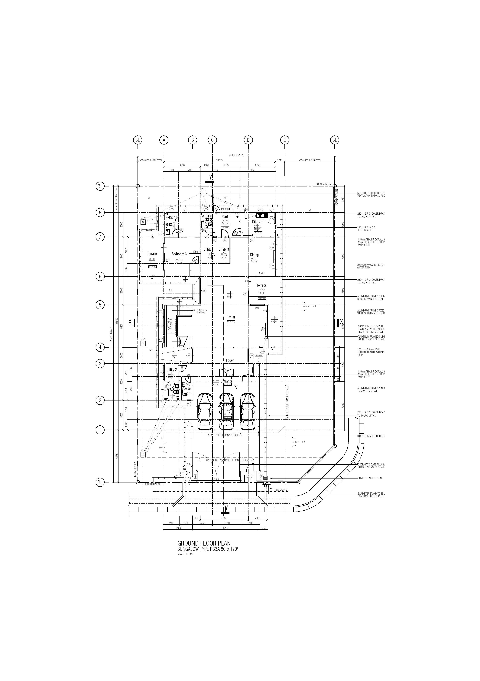

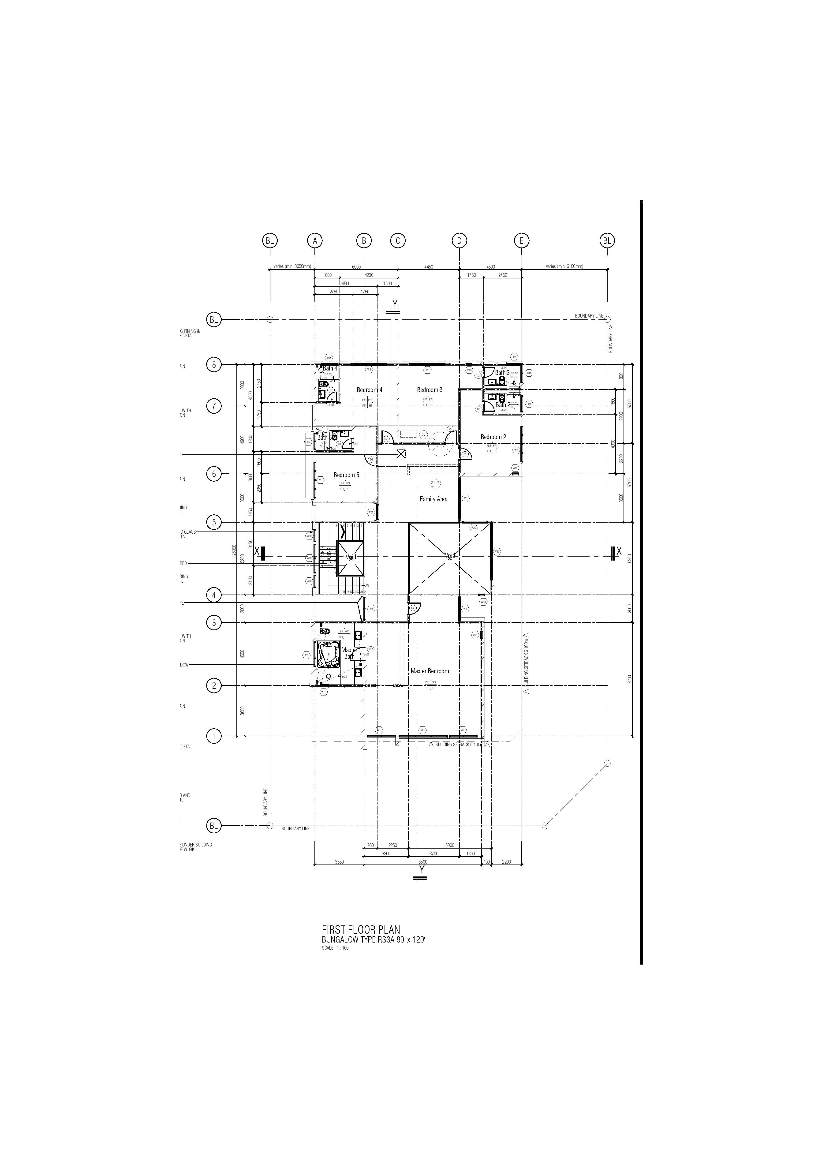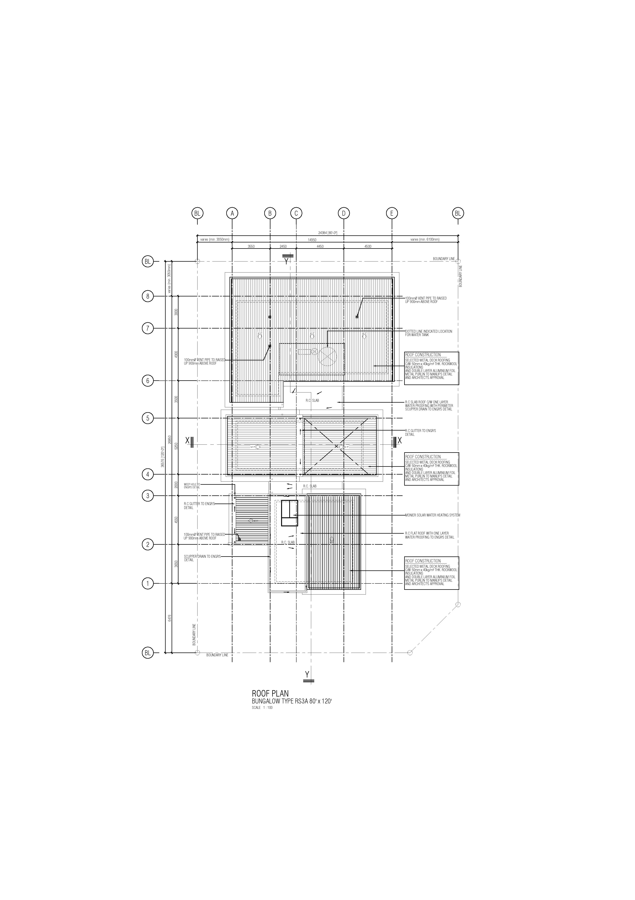

Structural Plan



Placement of columns on the ground floor

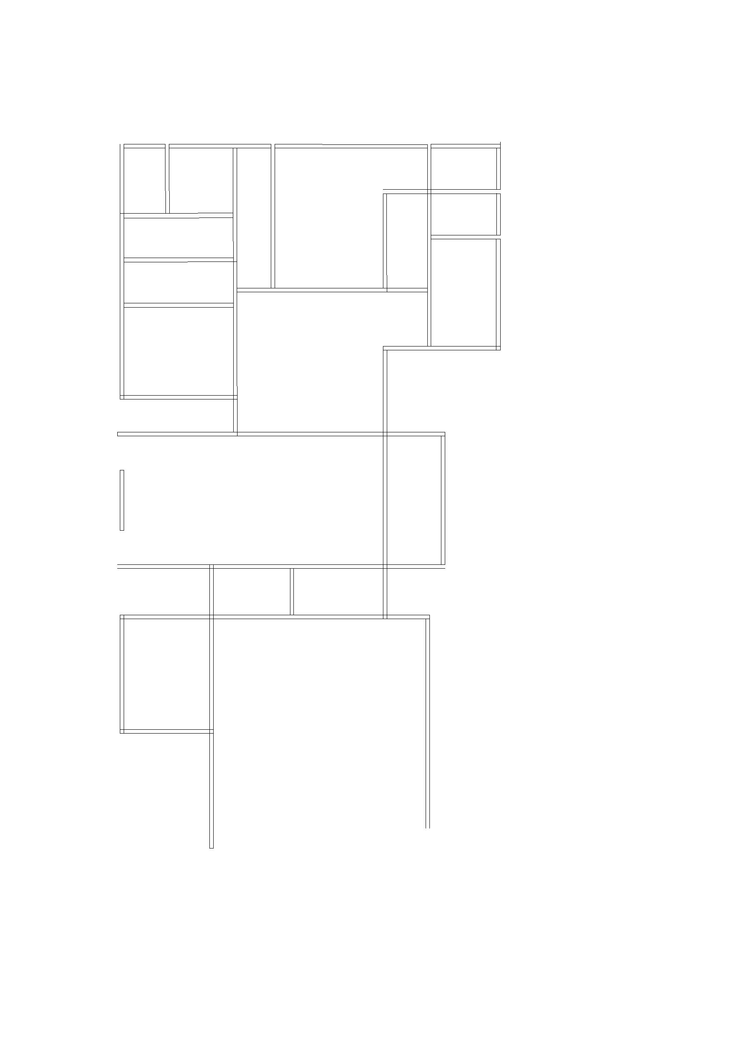

Placement of beams on the ground floor



Placement of columns on the first floor.

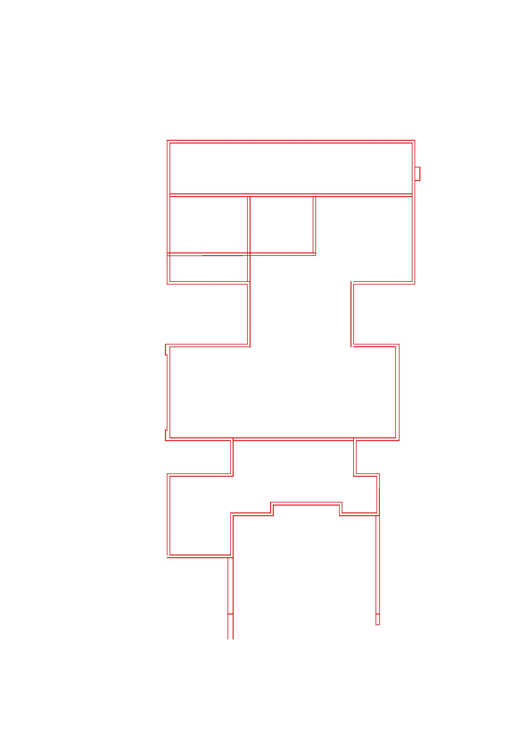

Placement of beams on the first floor.