
Cheah Eugene (1001GH77034)
Visagan Arudselvan (0313710)
Ivan Ling (0313583)
Naajid Naseem (0311649)
Preshan Rasu (0312813)
Masoud Ramedani (0317820)
INTRODUCTION

This project was for the Building Structures. In a gathering of six students are relegated to assemble a bridge fettuccine as the materials for the extension truss individuals. The bridge heaviness should not be more than 80g, but rather is required to convey a much bigger weight for a developed period of time.
The bridge’s span should be 350mm at least and students are to accomplish a high proficiency with their bridge. As a whimsical building material, the fettuccine represent a new material that could be brought into the business later on. With numerous obscure variables, including its pressure and strain abilities, students are requested that test and focus the best plan for an extension.
Students will figure out how to investigate truss individuals utilizing diverse game plans to accomplish the best execution and how to construct the ideal truss, One of the methods for deciding the qualities and shortcomings of the fettuccine was just to test its strain and pressure capacities, Through the contextual analyses, students will apply the learning frothed in class to ascertain the minute power, response power, inner drive, and compel dispersion of a truss And accordingly students will then have the capacity to distinguish which individuals from the truss framework must be fortified in its pressure or pressure constrain.
The reason for the point of reference studies was to utilized as a reference on the most proficient method to property outline an effective truss span which is compulsory for be gathering of understudies. This report contains data in regards to the students examination and documentation of the experimentation with a few fettuccine truss span designs. Individual contextual investigations are additionally in this report along with knowledge and recommendations for development.

EQUIPMENT AND MATERIAL USED
1. San Remo fettuccine
The most common brand of fettuccine was San Remo, as it was most easily available to us, and more cost effective than other imported brands


2. 500 ml water bottle: used during the load testing of the bridge. We used a local brand bottle because it was more accessible and much cheaper.
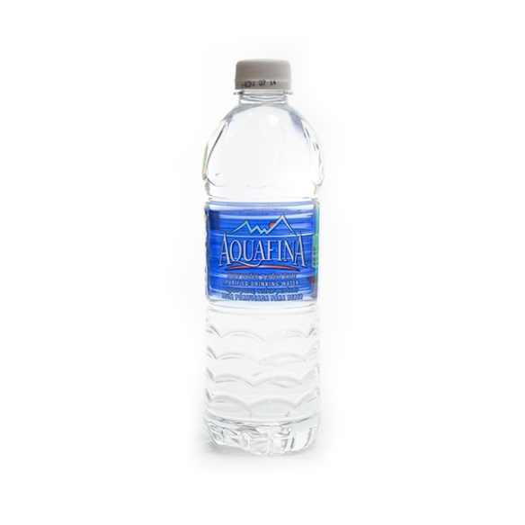
3.Cutting mat: used to protect the table surface cutting the fettucine. Each group member had their own cutting mat, so it may have different in size , how ever the function remains the same.
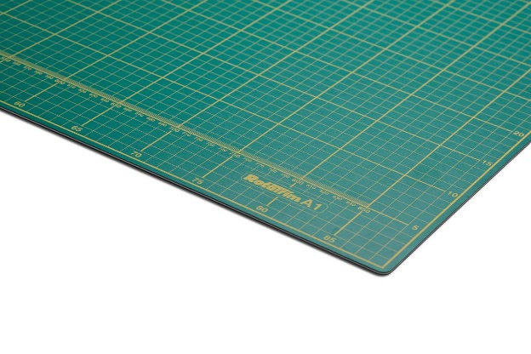

4. NIKON camera: used to capture and record the load testing process. The model we used was the D5100 Nikon.

5. Super glue: used during the second attempt when gluing the bridge join together. However m after discussing with our lecturer, we found out that the bridge truss would be brittle if the bridge is left after 2 days, hence , this might affect the strength and efficiency of the bridge.
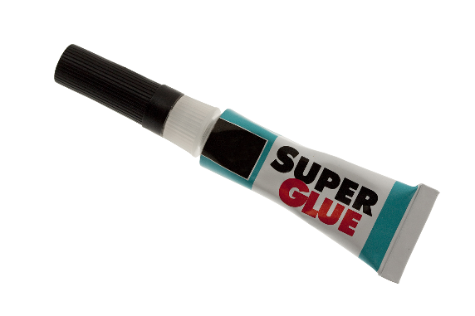

6. Laptop: used for reaserching precendent studies , references and also for the analysng of the report.


7.Ruler: used to measure and making on each fettucine before cutting it , metal rulers are more durable and therefore more ideal when slicing with the pen knife.

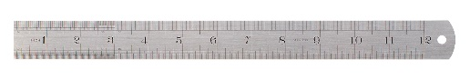

8.Knife: used to cut the fettucine to pieces during making of the bridge truss, each group member had their own knife , so the design of the knife may have been different.
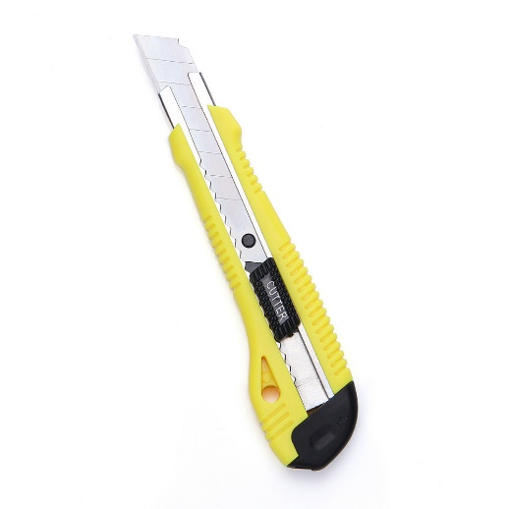
9.Bucket: used as a load by filling it up with water during the load testing.
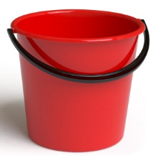

10.Digital Weight Machine: to mesure the weight of the bridge truss and the weight of the load applied on the bridge.
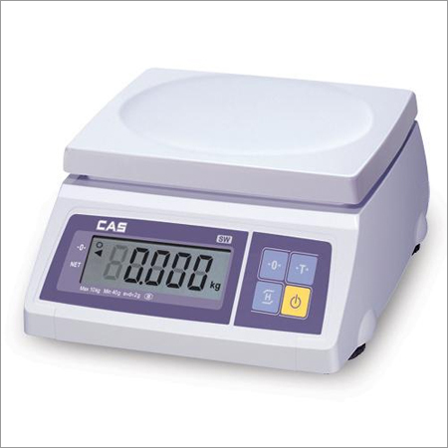

CHAPTER 2
METHODOLOGY
Our task was to design an efficient truss bridge by using fettucine as the only material. We started off by conducting precedent studies about existing bridges Afterwards, an analysis of the material attributes were done to test the strength of the material.
MATERIAL STRENGTH TESTING
The material fettucine was tested both for compression and tension by pulling the ends (tension) and by pushing them together (compression). From this we concluded that fettucine has a relatively great tensile strength and weak compressive strength
PRECEDENT STUDY
Precedent studies about existing bridges were done. This study was mainly focused on Betsy Ross Bridge and Kettle River Bridge. In this study, more emphasis were given to identify the connections of the bridges, the arrangement of members and the orientation of each member.
MODEL MAKING
From precedent studies and other references, two of the initial designs for the truss bridge were presented as sketches. This was then transferred to an autoCAD drawing with a clear span of 350mm. The two sides of the truss bridge model was constructed using AutoCAD and it was then connected by the immediate members. After using AutoCAD to design the bridge, preparations were done to make the physical model.
FIRST BRIDGE ATTEMPT
To start with, each of the fettucine was clearly observed for any deformities. After separating the bad (unusable) fettuccines, scissors were used to cut the fettucine members which were in good condition to the desired length. Each of the cut fettucine was further examined for the smoothness of the cut before it was glued. Afterwards, we used ‘action camera’ glue to connect each fettucine members together. After each of the fettucine members were glued together, we then waited for at least 10 seconds for it to dry.
The completed bridge was also left for a sufficient amount of time (24 hours) to dry before it was tested. It was then weighted to see how far or below the 80 g mark we were. In order to test the bridge, two tables of equal height were set exactly 750 mm apart. Next, the S hook and the bucket were both weighted to note the amount of load that the bridge would be exposed to. The S hook was then placed in the center point of the bridge and a piece of string was used to connect the S hook and the bucket handle.

The next step was to pour a full 500 ml water bottle slowly into the bucket, exposing the bridge to the load. The point where bridge is the weakest is then noted down. This was done by observing how the fettuccines were beginning to deform as it was exposed to the load. This was continued until the bridge failed to take in the load and broke. Next, the amount of water poured in was noted and examined (milliliters is equal to grams)
SECOND BRIDGE ATTEMPT
The mentioned steps are then repeated for the second bridge. However, depending on the data collected from the first bridge, the design was further refined for the second bridge and the parts that deformed quickly, were strengthened too.

CHAPTER 3
PRECEDENT STUDY
- BETSY ROSS BRIDGE
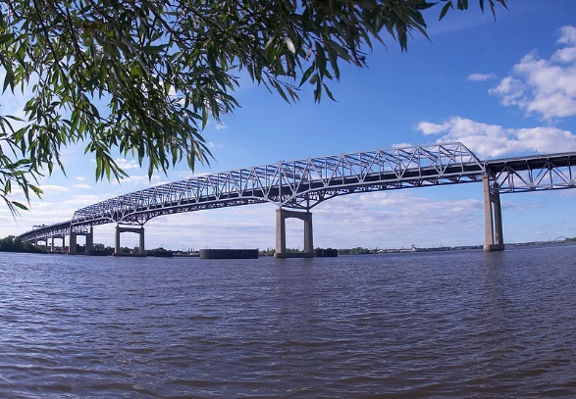 (Figure 3.1)
(Betsy Ross Bridge (Historic Review) , n.d.)
HISTORY
The Betsy Ross Bridge is a continuous steel truss bridge spanning the Delaware river from the City of Philadelphia in Pennsylvania to Pennasauken, New Jersey. It was built from 1969 to 1974 and opened in April 1976, during the American Bicentennial Year.

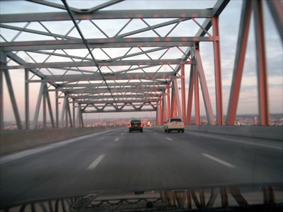 (Figure 3.2)
(Betsy Ross Bridge (Historic Review) , n.d.)

STRUCTURE
The bridge has a total length of 8,485 feet (2,586 m), and a main span of 729 feet (222 m). Though originally constructed with eight lanes, the bridge was reduced to six lanes with two shoulders in the year 2000.

LOAD ANALYSIS AND CONCLUSION
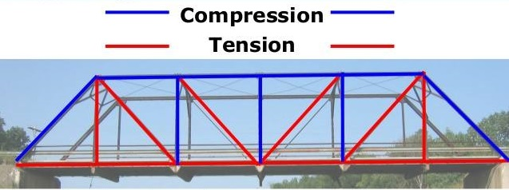 (Figure 3.3) (Boon, 2005)
The Betsy Ross Bridge uses a warren truss and the load is distributed in such a way that the diagonal bracing in the center of the bridge is in tension. Therefore, this design makes it efficient as the fettucine is good in tension and poor in compression
- KETTLE RIVER BRIDGE
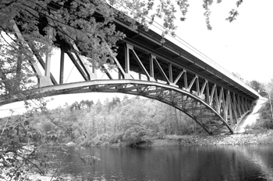 (Figure 3.4) (Transportation, n.d.)

HISTORY
The Kettle River Bridge, constructed in 1948, carries State Highway 123 over the Kettle River in Sandstone, Pine County. It is a three-span, rigid-connected, cantilevered, Pratt deck truss.
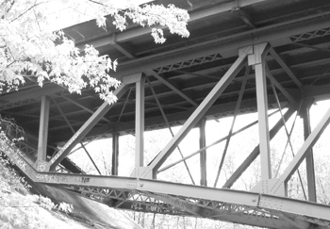(Figure 3.5)
(Transportation, n.d.)
STRUCTURE
The bridge consists of a system of two steel trusses (north and south) supporting a bridge deck ﬂoor system composed of a concrete deck supported by steel ﬂoor beams and ﬂoor stringers. Each truss system follows a Pratt Truss design with an arched bottom chord and is composed of three truss segments.
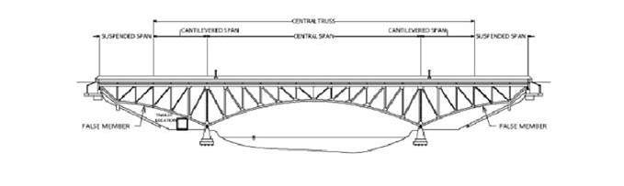(Figure 3.6)

- Spans 400 foot wide section
- Two parallel steel pratt trusses
- Bridge acts three separate spans.
- The central truss is of 300 foot and has a midspan of 200 feet which rests upon two conctrete piers on either side of the river as seen on the diagram.
- Two 50 foot cantilevered portions are on each end of the truss.

CONNECTIONS
- The central truss comes along with a pin type support at the west pier and an elastomeric pad at the east pier which is assumed as a roller type connection for analysis.
The west pier supports the truss system with a 17.8 centimeter (7 inch) diameter pin connection
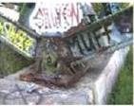 (Figure 3.7) (Transportation, n.d.)

- The east pier support uses an elastomeric bearing pad which allows for horizontal movement but resists vertical movement, creating a roller support condition

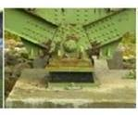 (Figure 3.8) (Transportation, n.d.)

- Both the east and west abutments of the trusses are supported by rocker supports resting on top of concrete abutments allowing horizontal movement in the east to west direction.
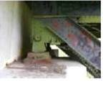 (Figure 3.9) (Transportation, n.d.)

LOAD ANALYSIS AND CONCLUSION
- The Kettle River Bridge uses a Pratt truss in which the load is distributed as follows.
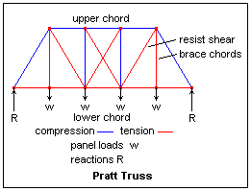 (Figure 3.10) (Boon, 2005)

CHAPTER 4
EXPERIMENTATION AND PROGRESS
MOCK UP BRIDGE (NOT FOR TESTING)
The main reason for a mock up bridge was to practice our way with fettuccines and to find out which of the glue or adhesive agent works best with it. Therefore, as for the design, a simple Pratt truss was used.
By the making of this bridge we narrowed down several factors that would affect the efficiency of the bridge
Workmanship
To start with, it was important to remove the bad fettuccines from the good ones. Moreover, the bridge was stronger and more stable when uneven layers of fettuccines were avoided.
Height of the bridge
The height of the mock up bridge was relatively high, which in turn reduced the stability and strength of the bridge
Strength of the fettucine member
In the mockup bridge, fettuccines members were used both vertically and diagonally. We learnt that it was important to note down which members were in compression and in tension before adding more layers of fettuccines to increase the strength of each member
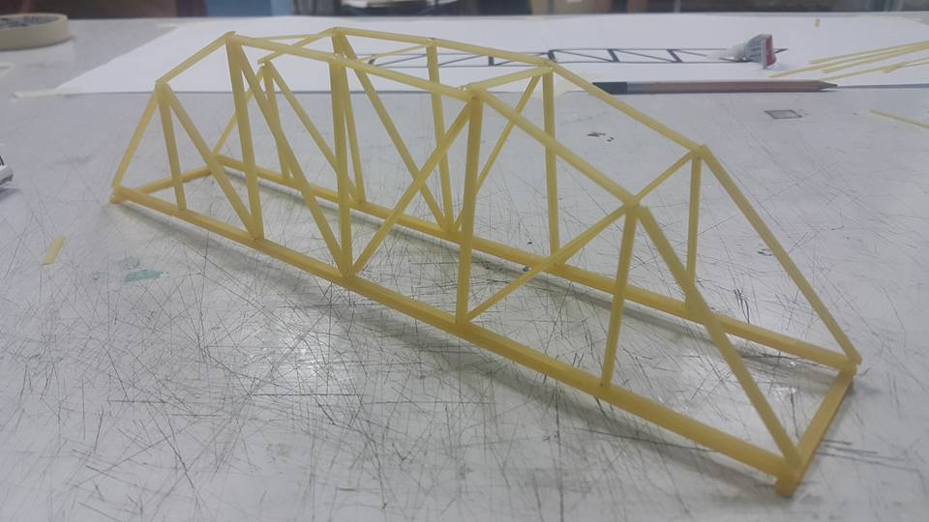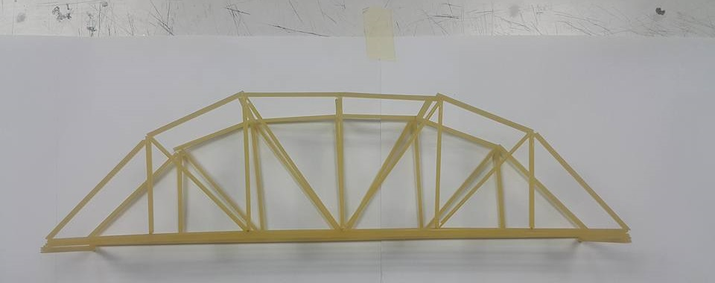
(Figure 4.1) (Mockup Bridge) (Figure 4.2)

BRIDGE TESTING 1
Our intention for the first bridge was to keep the design as simple as possible. A basic warren truss design was used to for the initial bridge since the diagonal bracing is in tension in this type of trusses, as per the precedent study.
It is important to note that, additional layers of fettuccines were added to the lower rail section and the upper rail section, to make the bridge stronger and more stable. In addition to this sufficient time was given for each of the joined fettucine members to dry, after joining each of the member using ‘action camera’ glue.
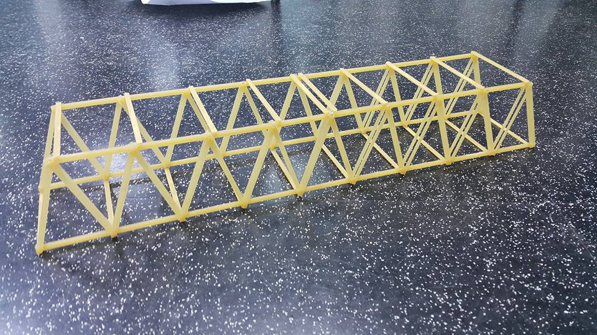 (Figure 4.3)
Clear span: 350 mm
Total length: 450mm
Height of the bridge: 70 mm
Weight of the bridge: 67 g
Total load withstand: 1114 g
= (1.114)² / 0.067
= 1.241/0.067
= 18.52 %
Efficiency: 18.52 %

TEST RESULTS

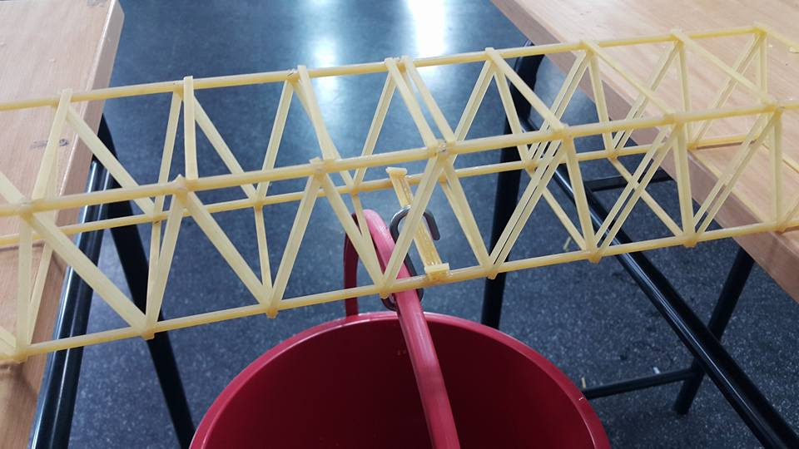 (Figure 4.4)
It was the horizontal member in which the hook was placed, that broke off. As per the test result, we concluded that this might be due to the lack of strength of the horizontal member in which the hook was placed. However, adding several layers of fettuccines to the lower rail section of the bridge, did make it stronger. A solution as per the test result would be to make each of the horizontal member stronger by adding more layers of fettuccines.
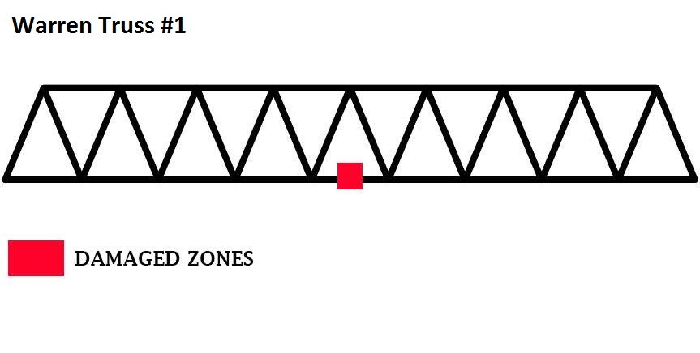
(Figure 4.5)
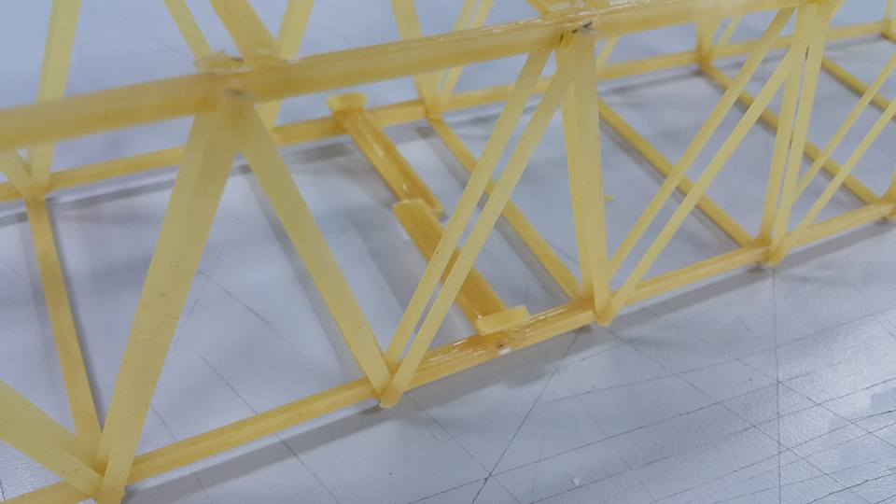 (Figure 4.6) (After testing)

BRIDGE TESTING 2
As per the results from the initial test bridge, the warren truss design was further improvised aiming to increase the total load withstand and efficiency of the bridge. This was done by keeping the height of the bridge same as the first one. However, additional layers of fettuccines were added to members to make it stronger.
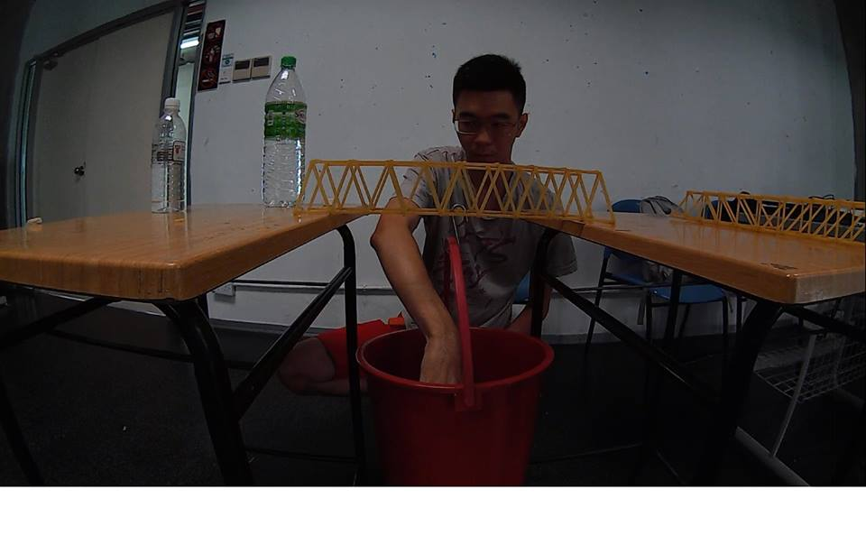
(Figure 4.7)
Clear span: 350 mm
Total length: 450mm
Height of the bridge: 70 mm
Weight of the bridge: 67 g
Total load withstand: 1698 g
= (1.698)²/0.067
= 2.883/0.067
= 43.03 %
Efficiency: 43.03%
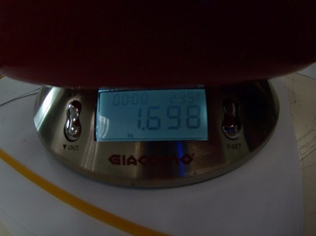 (Figure 4.8)

TEST RESULTS
Our objective was achieved as the second bridge was able to withstand a higher load and efficiency compared to the first bridge. We managed to do so by keeping the height of the second bridge same as the first one.
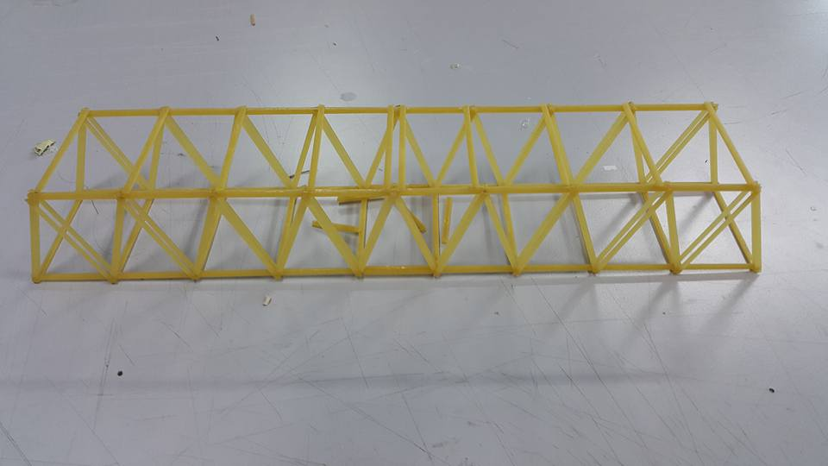
(Figure 4.9) (After testing)
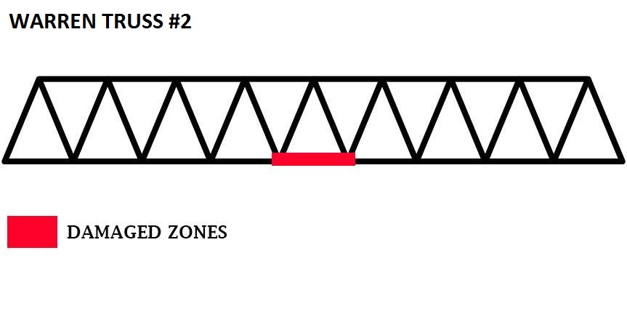
(Figure 4.10)
When making of the second bridge, special attention was given to workmanship and strength of individual members of fettuccines. Little improvisation was done from the first bridge, therefore it was the same member that broke off in the second bridge as well. From second bridge testing, it can be concluded that good workmanship and strength of individual members play an important role in withstanding more load and increasing of efficiency.

BRIDGE TESTING 3
As for the third bridge we decided to go with a different truss design mainly to observe how well fettuccines work with other trusses. Considering all this, we chose a Pratt truss design as our second bridge. As per the precedent study, it was noted that the Pratt truss design has diagonal members in tension which would be more efficient when making the bridge using fettuccines. This is because fettuccines have a relatively good tensile strength
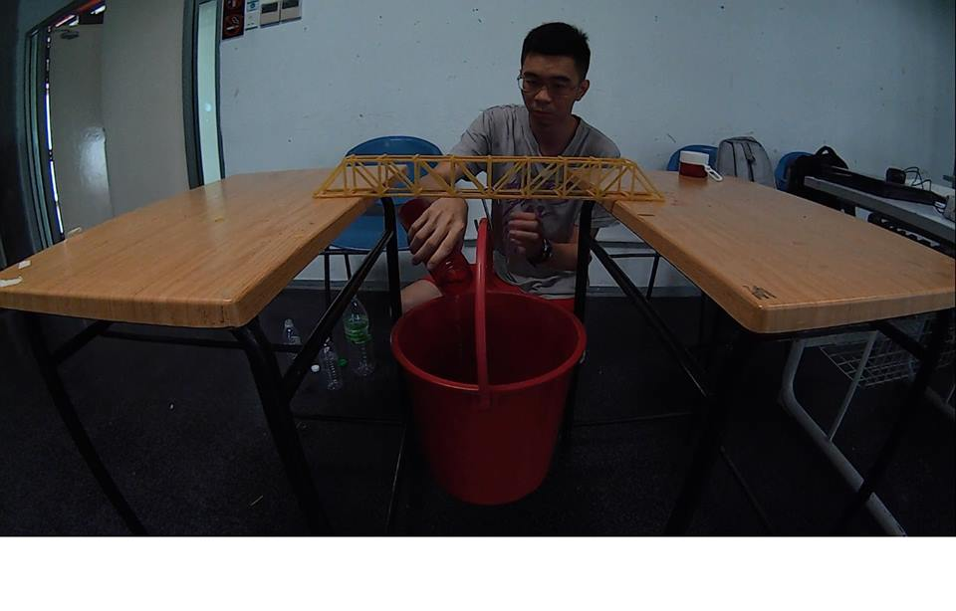
(Figure 4.11)
Clear span: 350 mm
Total length: 500mm
Height of the bridge: 70mm
Weight of the bridge: 69 g
Total load withstand: 3138 g
= (3.138)²/0.069
= 9.847/0.069
= 142.71%
Efficiency: 142.71 %
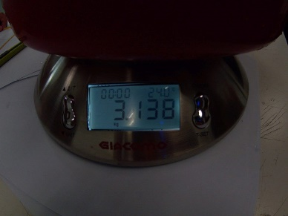 (Figure 4.12)

TEST RESULTS
The main intention of our second bridge was to increase the total load withstand and the efficiency of the bridge compared to the first two bridges. We succeeded in increasing the total load and the efficiency of the bridge.
After the initial bridge testing, special consideration was given to strengthen each of the fettucine member. Therefore, additional layers of fettuccines were added to each of the member in the second bridge. In addition to this, the total height of the bridge was also reduced to increase the strength and stability. Considering all this, the overall efficiency of the bridge was greatly increased.
After these test results, it was concluded that one way to increase the overall efficiency, was to increase the total load withstand of the bridge by keeping the weight of the bridge as minimal as possible.
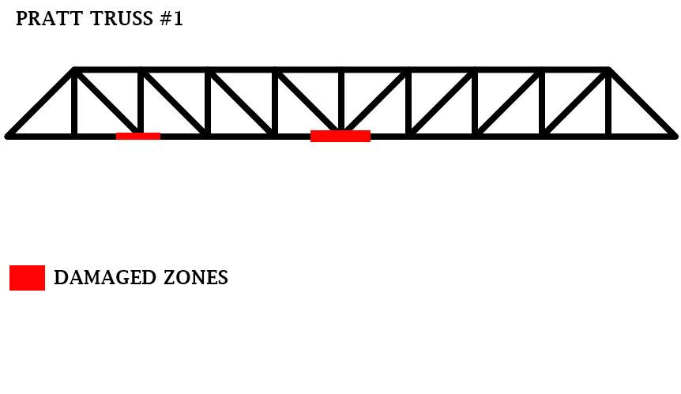
(Figure 4.13)
Although the bridge was able to take more load, it broke off in two places when subjected to a load of 3138 g. We suspect that the bridge broke off in the lower rail of the left side (as seen on the diagram) due to poor workmanship (uneven fettuccine layers) or because insufficient time was given for the glue to dry.

FINAL BRIDGE
Having tried both Warren and Pratt trusses, the results showed that Prat trusses were more efficient when fettuccines were used. Therefore, Bridge 3 was further improvised, with additional layers added each of the fettuccine membrane to make it stronger.
Our main objective for the final bridge was to increase the load withstand as much as we could by not exceeding the weight of the bridge by 80 grams.
Based on our previous bridge testing results, 6 layers of fettuccines were added to the upper rail section and lower rail section as these parts were exposed to more load.
In addition to this, thickness of the member in which the hook was placed was also increased which significantly increased the total load withstand.
Furthermore, the height of the bridge was also reduced which played an important role in achieving a higher efficiency.

Clear span: 350 mm
Total length: 400mm
Height of the bridge: 50mm
Weight of the bridge: 81 g
Total load withstand: 8050 g
= (8.05)²/ 0.081
= 64.803/ 0.081
= 800 %
Efficiency: 800%

TEST RESULTS
The final bridge was constructed 1 day prior to the bridge testing date. Therefore, the glue was properly dried and not too brittle. In addition to this, we focused on keeping the layers of fettuccines as straight as possible for each of the membrane. As a result uneven layers of fettuccines for the final bridge was avoided.
It is believed that the result for the final bridge was achieved by a combination of a lot of things such as, good workmanship, strength of each of the fettuccine members and height of the bridge as well.
Considering all these factors, our final bridge was able to take in 8050 grams of loads by weighing roughly 80 g.
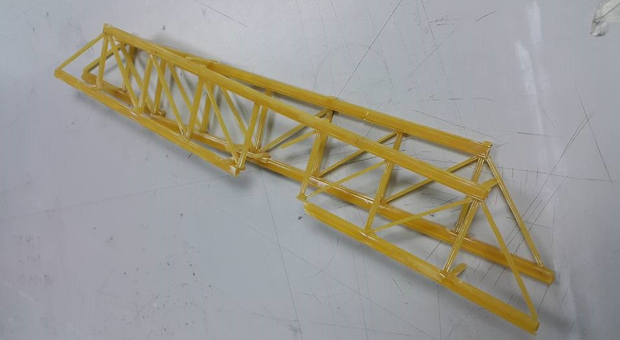
(Figure 4.14) (After testing)
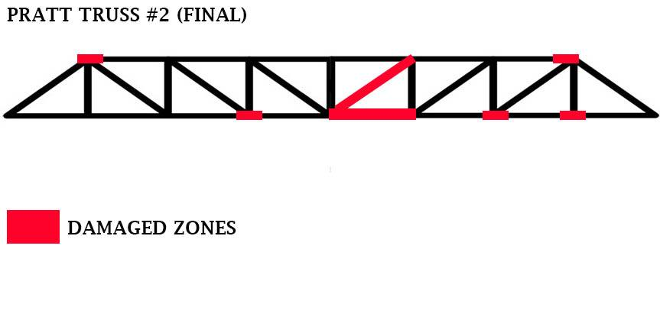
(Figure 4.15)
During the day of the testing, the bridge broke off from the middle when suspected to a load of 8050 grams. The part which broke off in the middle, was the member in which the hook was placed. Furthermore, the bridge also had several damaged zones (marked red in the diagram) which were mostly the connection joints between each member.

REFERENCES
Betsy Ross Bridge (Historic Review) . (n.d.). Retrieved from
http://www.phillyroads.com/: http://www.phillyroads.com/crossings/betsy-ross/

Boon, G. (2005, August ). Garrets Bridges . Retrieved from www.garretsbridges.com
http://www.garrettsbridges.com/design/trussdesign/

Transportation, M. D. (n.d.). Historic Bridges. Retrieved from
http://www.dot.state.mn.us: http://www.dot.state.mn.us/historicbridges/5718.html

Wai-Fah Chen, L. D. (2000). In L. D. Wai-Fah Chen, Bridge Engineering Handbook
(Second edition) (p. 3130 ). 1500 B/W Illustrations.

Case 1: Naajid Naseem
Case 2: Eugene Cheah
Case 3: Visagan Arudselvan
Case 4: Masoud
Case 5: Ivan Ling

