

SCHOOL OF ARCHITECTURE, BUILDING & DESIGN
BACHELOR OF SCIENCE (HONOURS) IN ARCHIETCTURE
BUILDING SCIENCE II ( BLD61303 )

PROJECT I :
LIGHTING & ACOUSTIC PERFORMANCE EVALUATION & DESIGN

SOMETHING FISHY, SS15

STUDENT | ID
PATRICIA KONG
KIMBERLY WONG
VALENTINE HEW HUI LING
NAAJID NASEEM | 0311649
MASRUR AKMAL JAMAL | 0315141
ADIBAH BAHIAH AWANG | 0316318

TUTOR : MR AZIM SULAIMAN

TABLE OF CONTENT

1.0 INTRODUCTION 6

  - Aim & Objective 7

1.2 Site 7
1.2.1 Introduction
1.2.2 Technical Drawings

2.0 LIGHTING PERFORMANCE EVALUATION 11

2.1 Literature Review 12
2.1.1 Architectural Lighting
2.1.2 Daylight Factor
2.1.3 Lumen Method

2.2 Precedent Studies 15
2.2.1 Introduction
2.2.2 Daylighting
2.2.3 Artificial Lighting
2.2.4 Conclusion

2.3 Research Methodology 19
2.3.1 Light Measuring Equipment (Digital Lux Meter)
2.3.2 Data Collection Method

2.4 Case Study 23
2.4.1 Introduction
2.4.2 Zoning

2.5 Existing Lighting Conditions 28
2.5.2 Existing Light Fixtures
2.5.2 Materials

2.6 Lighting Data Analysis 34
2.6.1 Daytime Lux Reading
ZONE A
ZONE B
ZONE C
2.6.2 Night time Lux Reading
ZONE A
ZONE B
ZONE C
2.6.3 Observation & Discussion

2.7 Lighting Calculation Analysis 38
2.7.1 Daylight Factor Analysis
ZONE A
ZONE B
ZONE C
2.7.2 Artificial Lighting Analysis
ZONE A
ZONE B
ZONE C

2.8 Conclusion 48

3.0 ACOUSTIC PERFORMANCE EVALUATION 49

3.1 Literature Review 50
3.1.1 Architectural Acoustic
3.1.2 Sound Pressure Level (SPL)
3.1.3 Reverberation Time (RT)
3.1.4 Sound Reduction Index (SRI)

3.2 Precedent Studies 53
3.2.1 Introduction
3.2.2 Conclusion

3.3 Research Methodology 55
3.3.1 Acoustic Measuring Equipment
Digital Sound Meter
Camera
Measuring Tape
3.3.2 Methodology
3.3.3 Data Collection Procedures

3.4 Case Study 58

3.5 Existing Noise Sources 58
3.5.1 External Noise
Site Context
Vehicles
3.5.2 Internal Noise
Human Activities
Speakers
Electrical Appliances
3.5.3 Location of Noise Sources

3.6 Materials and Properties 65
3.6.1 Furniture Material
3.6.2 Wall Material
3.6.3 Ceiling Material
3.6.4 Floor Material

3.7 Acoustic Tabulation Analysis 65
3.7.1 Sound Intensity Level (SIL)
ZONE A
ZONE B&C
Analysis
3.7.2 Reverberation Time (RT)
ZONE A (PEAK)
ZONE A (NON PEAK)
ZONE B (PEAK)
ZONE B (NON PEAK)
Analysis
3.7.3 Sound Reduction Index (SRI)
ZONE A , WALL A
ZONE A , WALL B
ZONE B & C , WALL C
ZONE B & C , WALL D
3.7.3 Analysis

3.8 Conclusion 88

4.0 BIBLIOGRAPHY 89


1.0
INTRODUCTION

1.1 Aim & Objective

The project aims to educate students on the study of lighting and acoustics and its relevance to architectural design. Lighting is an essential aspect of the design of space as it illuminates the entire space, as well as adding aesthetic values and creates the mood and ambiance of space. The success of the lighting of a building is measured by the standard required amount of lighting used in a space, and it is also recognised as a main element that ensure the quality of space.

Acoustic design is about the propagation of sound and how it interacts with the surfaces and objects within a space.

This project is designed to expose students to the methods of designing the proper lighting and acoustic systems in a building through observing the conditions of the existing lighting and acoustic system through case studies, and critically analysing these components to further understand the study.

1.2 Site

1.2.1 Introduction

Our chosen site for this project is Something Fishy- a restaurant/cafe located along Jalan SS15, Subang Jaya. Co-owned by two young Malaysian, this cafe has been operating since of late 2014, and has become a popular hotspot along the street, mainly due to its late operating hours and a variety of food options. This specific site has been chosen as our case study primarily because of its high human density, and unique lighting choices.

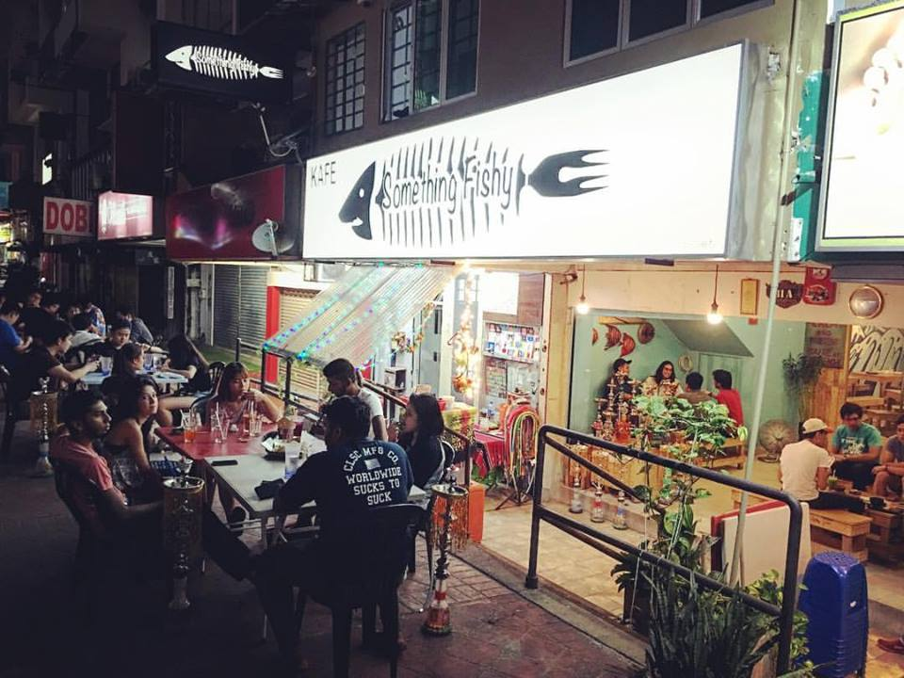

Figure 1.2.1.1 : Café exterior
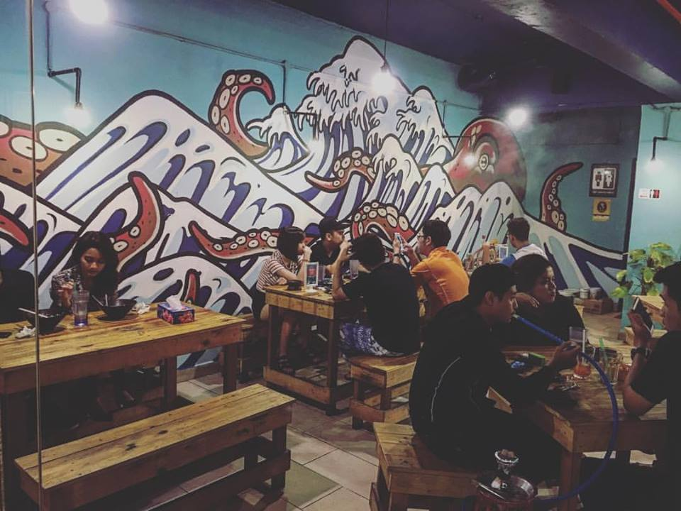

Figure 1.2.1.2 : Café interior
1.2.2 Technical Drawings

Figure 1.2.2.1 : Floor Plan

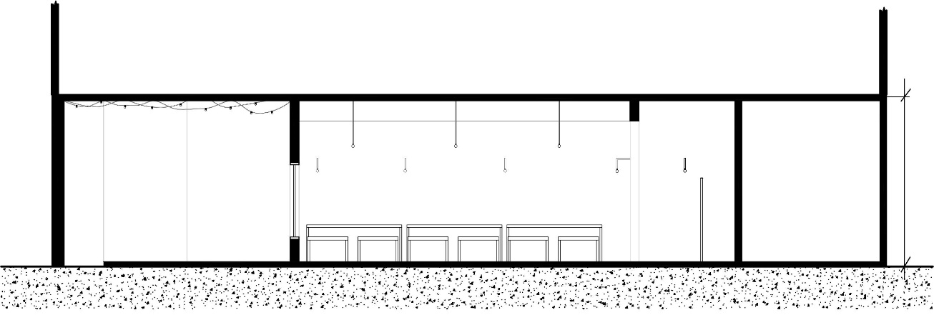
Figure 1.2.2.2 : Section

The café consists of a basic shop lot floor plan. The space continues all the way from front to back, with minimum partitions and sections. The café opens both front and back and it has a height of 3500 mm

2.0
LIGHTING PERFORMANCE EVALUATION

2.1 Literature Review

2.1.1 Lighting in Architecture
Lighting is an extremely important element in architecture as it provides illuminance which deals with the safety and comfort of the occupants. Sun is the prime source of daylight and the spaces should be designed to provide light according to the occupants’ function and should prevent lighting problems such as glare. There are different types of artificial lighting which is also dependent on occupants’ function.

2.1.2 Natural and Artificial Lighting Factor
It is essential to understand the limitations and opportunities in using both natural light and artificial light and their capabilities in order to apply it into architecture to achieve maximum performance of a building. The lighting factor may also change depending on the typology of a building. For instance, vast exposure to natural light in museums and galleries may cause damage to the artifacts.

2.1.3 Daylight Factor
Daylight factor is the ratio of the light level inside the structure to the light level outside the structure, possible from an unobstructed hemisphere in the sky. It is done to obtain the sufficient natural light needed for the occupants to carry out their activities.

Daylight Factor, DF = Indoor Illuminance, Ei / Outdoor Illuminance, Eo x 100%

Where, Ei = Illuminance due to daylight at a point on the indoor working planes

Eo = Simultaneous outdoor illuminance on a horizontal plane from an unobstructed hemisphere of overcast sky.

Zone | DF (%) | Distribution
Very bright | >6 | Large (including thermal and glare problem)
Bright | 3–6 | Good
Average | 1 -3 | Fair
Dark | 0–1 | Poor

Table 2.1.3.1 : Daylight factor and distribution

2.1.4 Lumen Method
Lumen method is used to determine the number of lamps which should be installed in a given space if they are to be mounted in a regular pattern. For the calculation of lumen method, lumen of each lamp used and the size of the room are needed in addition with the details of the lamp and room surface.
The number of lamps can be calculated by the formula below:

N = E x A / F x UF x MF

Where by:

N = Number of lamps required.

E = Illuminance level required (lux).

A = Area at working plane height (m2)

F = Average luminous flux from each lamp (lm)

UF = Utilisation factor, an allowance for the light distribution of the luminaire and the room surfaces.

MF = Maintenance factor, an allowance for reduced light output because deterioration and dirt.

In order to find the utilization factor, room index is needed in addition with the reflectance suraface value.
Room Index, RI, is the ratio of room plan area to half wall area between the working and luminaire planes. Room Index can be calculated by:

RI = L x W / Hm x (L + W)

Where by:
L = Length of room.

W = Width of room.

Hm = Mounting height, the vertical distance between the working plane and the luminaire.

2.2 Precedent Study

2.2.1 Introduction
Place: England (London)
Building Type: Residential Home
Contact: Geoff Beardsley & Partners (UK) LLP
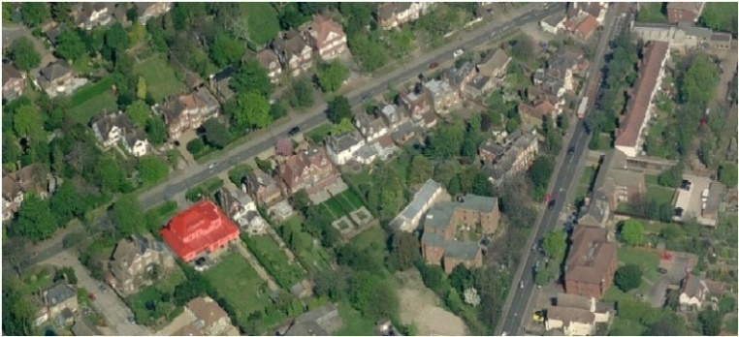
Figure 2.2.1.1 : Site location showing the red mask “as existing”

The assessment was undertaken to see the effects of the neighboring property at 101 Ditton Rd, if the 1st floor extension at 99 Ditton Rd, goes ahead as proposed. It looks at the impact of all direct and indirect sunlight during daytime when considering the impact of new development on existing property.
Parameter | BRE Report Reference | Criteria | Acceptability Criteria
Daylight | Section 2.2 | Any part of the new building measured in a vertical section perpendicular to a main window wall subtends an angle of less than 25° to the horizontal | Any part of the new building measured in a vertical section perpendicular to a main window wall subtends an angle of less than 25° to the horizontal
Daylight | Section 2.2 | Vertical Sky component | Reduction from existing not more than 20%. Its former value if VSC is less than 27%
The results were then compared with the acceptability criteria by BRE
Table 2.2.1.1 Summary criteria from BRE report to assess the impact of the proposed developments
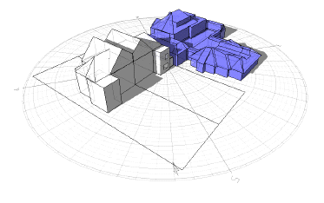
Figure 2.2.1.2 : Massing “as existing” at 99 Ditton Rd, in solid blue and adjoining buildings in white
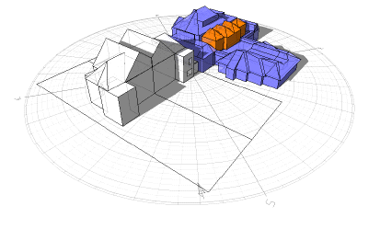
Figure 2.2.1.3 : Massing “As existing” at Ditton Rd in solid blue with the proposed 1st floor extension

2.2.2 Daylighting

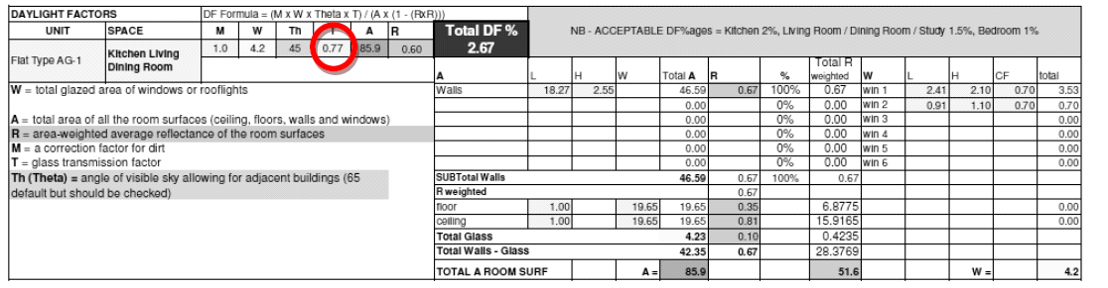
The daylight factors were measured in the existing property at 101 Ditton Road on 21 March 2015. Table xxx shows the spreadsheets for the calculation of the average daylight factor
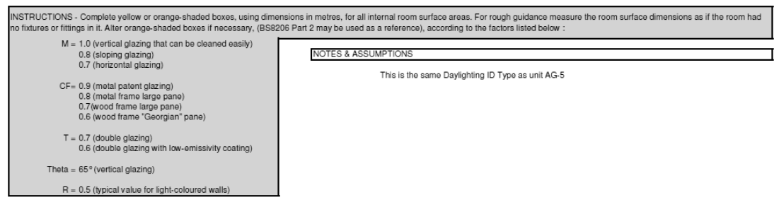
Table 2.2.2.1 : Spreadsheet for the calculation of average daylight factor

Daylight Factors in the existing property were calculated with the proposed 1st floor extension. They were then compared with the existing daylight factors of the property to analyze the percentage of reduction.

Window | Adjoining Property | Existing Conditions % | Proposed 1st Floor Extension % | Minimum VSC to Achieve Compliance % | Difference % (Maximum +20%) | Complies with BRE guidelines
1 | 101 Ditton Rd | 62.2 | 60.6 | 49.76 | 2.57% | YES
2 | 101 Ditton Rd | 20.6 | 20.4 | 16.48 | 0.97% | YES
3 | 101 Ditton Rd | 18.1 | 18.1 | 14.48 | 0.00% | YES
4 | 101 Ditton Rd | 17.3 | 16.8 | 13.84 | 2.89% | YES
5 | 101 Ditton Rd | 40.9 | 38.6 | 32.72 | 5.62% | YES
6 | 101 Ditton Rd | 10.2 | 10 | 8.16 | 0.79% | YES
7 | 101 Ditton Rd | 12.6 | 12.5 | 10.08 | 0.79% | YES
8 | 101 Ditton Rd | 12.4 | 11.7 | 9.92 | 5.65% | YES
Table 2.2.2.2 : Daylight factor in windows and skylight at 101 Ditton Rd – Proposed 1st floor extension at 101 Ditton Rd.

If the vertical sky component is greater than 27% then enough skylight should still be reaching the window of the existing building. Any reduction below this level should be kept to a minimum. If the vertical sky component, with the new development in place, is both less than 27% and less than 0.8 times its former value, then occupants of the existing building will notice the reduction in the amount of skylight. The area lit by the window is likely to appear gloomier, and electric lighting will be needed more of the time.

As shown in Table 02, the adjoining property at 101 Ditton Rd does not notice a reduction in current daylight levels if the proposed 1ST Floor extension at 99 Ditton Rd goes ahead as proposed.

All of the potentially affected windows show an acceptable reduction in daylight levels in comparison with the existing conditions. The daylight difference to neighbours vary from 0% reduction (window # 3 at 101 Ditton Rd) to maximum 5.65% (window # 8 at 101 Ditton Rd). As these daylight reduction is less than 20%, the proposed development complies well within the BRE guidelines for daylight access.

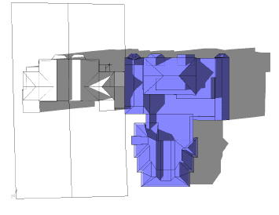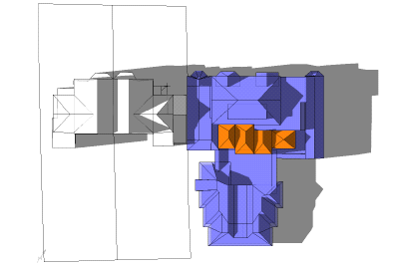
Shadow development . Shadow development “Proposed
“as existing” – plan view first floor extension” plan view
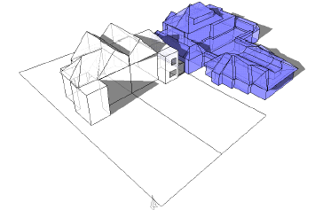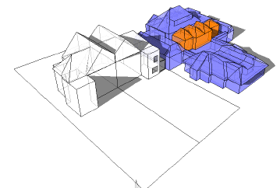
Shadow development “As existing” Shadow development “as
- Perspective view proposed 1st floor extension” - perspective

2.2.3 Conclusion

Natural Light is a very important factor in architecture and it can be affected by a lot of things. Adjoining Buildings are one of the factors that could affect the natural light being penetrated into a building. Therefore, it is important to consider the whole context when designing reducing the negative impact of any proposed building. The assessment undertaken demonstrates that the existing property at 101 Ditton Rd, would not notice a reduction in Daylight and sunlight levels if the proposed 1st floor extension at 99 Ditton Rd takes place as proposed.

2.3 Research Methodology

2.3.1 Primary Literature Review

The research is done on a specific building chosen and study the lighting performance in the space which is applied to the case study. With the readings done which gives us better understanding on how the lighting performance in the site works. The readings are taken in both indoor and outdoor space to evaluate the artificial and natural during the day and night.

2.3.2 - Lighting Measuring Equipment

Digital Handheld Light Meter

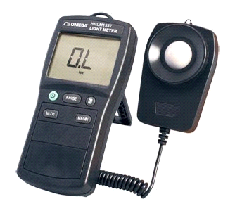
Source: http://www.omega.com/pptst/HHLM1337.html

A handheld meter with a large display screen for easy viewing of the light levels readings. It can measure at a wide range of either LUX or foot-candles. The applications which includes both indoor light and outdoor work area of lighting, the monitoring and verification to measure illuminance and the performance of the light in the space. It is run by a battery.

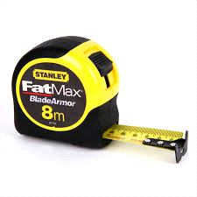
Measuring Tape

Source: https://2ecffd01e1ab3e9383f0-07db7b9624bbdf022e3b5395236d5cf8.ssl.cf4.rackcdn.com/Product-800x800/a6ed4d08-7772-4350-8d33-3ec9d39fa3b6.png

This equipment is to measure and indication of the distance of each grid of the floor area of 1.5m by 1.5m where the light source is measured by height level and waist level of a person.

Digital Camera
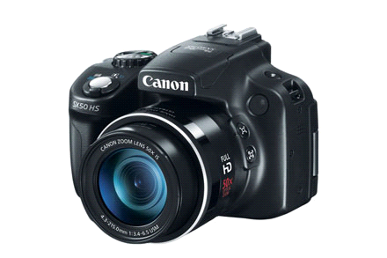
Source: https://shop.usa.canon.com/wcsstore/CanonB2BStoreFrontAssetStore/images/25592_1_l.jpg

The digital camera is used to capture the visual image of the condition of the space including the indication of the light source, materials and light performance of the space during the day and night time.


Laptop

Source: http://www.mrrental.com.au/media/computers-office/v5-431p-05_-copy.jpg?sfvrsn=0

The laptop is used to draw the indication of grids in the floor plan and section of the space after the measurements of the café is taken.

2.3.3 Data Collection Method

Methodology

- The site is chosen for the research due to the suitable light source, windows and enclosed space.
- Research and experiment conducted with permission from the site owners
- The entire research is held at 1.5m by 1.5m grid throughout the whole space together with technical drawings produced.
- The light level is experimented from the indoor and outdoor space.
- The light level is compared among each readings taken from every grid.
- Calculation and analysis is conducted with conclusion with the recorded readings.

Data Collection Procedure
- The grid lines within 1.5m by 1.5m were drawn in order to obtain correct data collection.
- Specify the obstacles such as extended beams, which will affect the light source, i.e low readings.
- Analyze the differences between the recorded readings between waist and eye level and come out with a conclusion if there is indifference in the readings.
- Ensure no obstacle between the meter device while recording to prevent shadows from affecting the readings
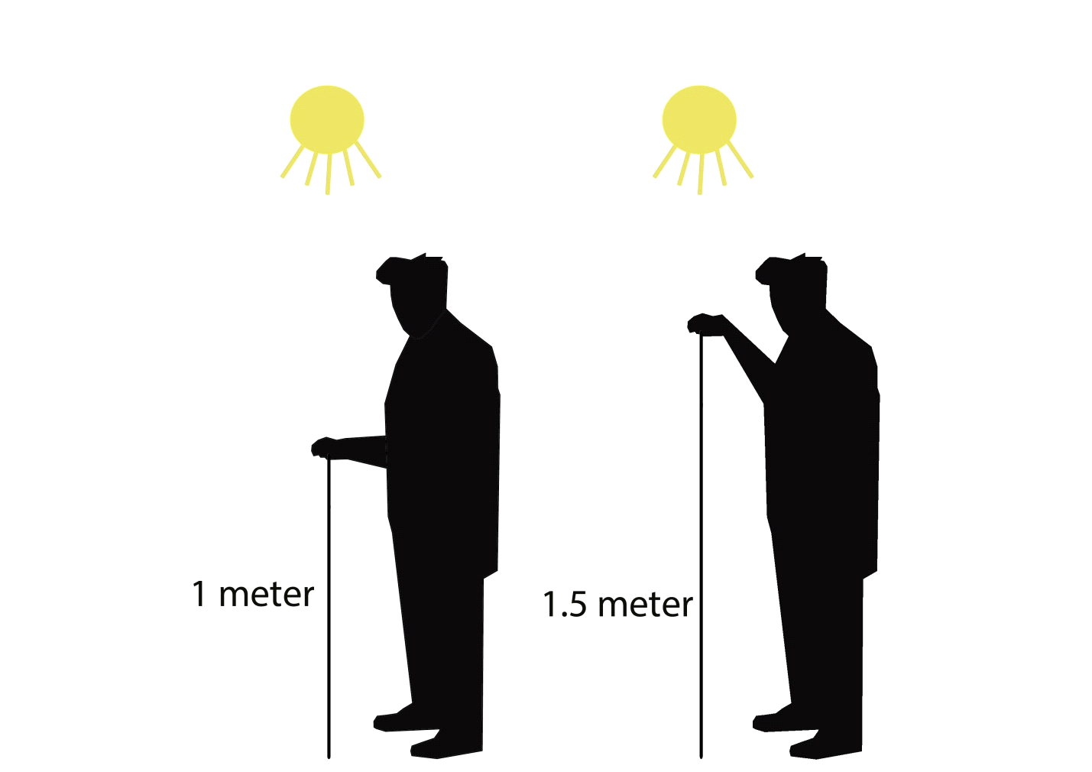
- Ensure the meter position is balanced when handheld during the recording of the readings.

Ground level
2.3.4 Limitations

There are some obstacles that will affect the light readings such as human shadows, furniture and building components such as beams that can be seen in the value of the readings. Therefore, caution to be made when indicating the nearby objects to the light source that cause the slight indifference between the readings in some area to be either too high or too low.
There is also limitation that caused by natural factors such as the weather, for example rain that will affect the lighting condition in the space.

2.4 Case Study

2.4.1 Introduction

Located in SS15, a place well known for various types of food, Something Fishy is one of the shops that serves Thai food alongside with Little Bali café and Vanilla the Milk Cream Café. This place is usually where most young adults and adults goes to for after work or class.
The building itself is located in a row of shop lot of the same height and the road is usually packed with cars during lunch and dinner hours. This site has very minimal sun shading similarly to its neighbouring site due to the orientation of the sun path (refer to 2.4.2 for more information).

2.4.2 Natural Light


Figure 2.4.2.1 : The exterior of Something Fishy

During the day time, the natural light penetrates the restaurant through the glass panels at the entrance. The entrance of the building, due to the glass panels have great quality of light penetrating into the building and the high reflective surface make it more visible. However the absence of natural light makes it dark towards the back of the restaurant.

2.4.3 Sun Path Analysis diagram
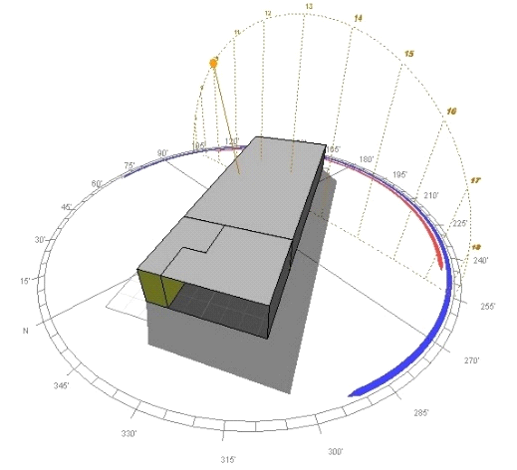
Figure 2.4.3.1 :
2nd November 2016, 10am
(Created using Autodesk Ecotect Analysis)

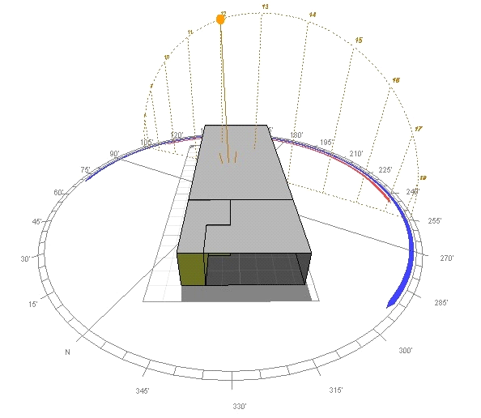
Figure 2.4.3.2:
2nd November 2016, 12pm(noon)
(Created using Autodesk Ecotect Analysis)

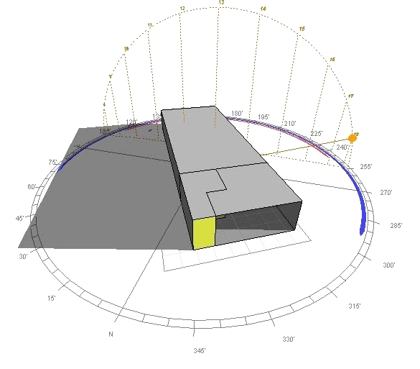

Figure 2.4.3.3 :
2nd November 2016, 6pm
(Created using Autodesk Ecotect Analysis)

2.4.4 Artificial Light
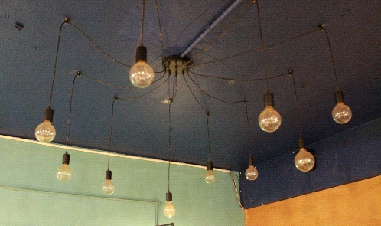
Figure 2.4.4.1 : overhang lights
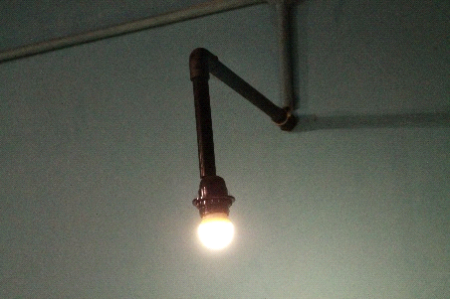
Figure 2.4.4.2 : wall mounted light
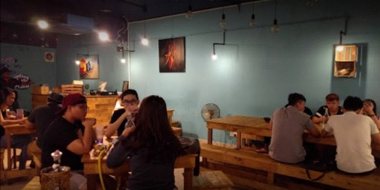
Figure 2.4.4.3 : eatery area during night time

The enclosed area of the restaurant has most of the artificial lighting with some overhanged and wall mounted artificial lighting. The artificial lighting in the restaurant gives it a very dim condition comfortable enough for eating.

2.4.5 Zoning

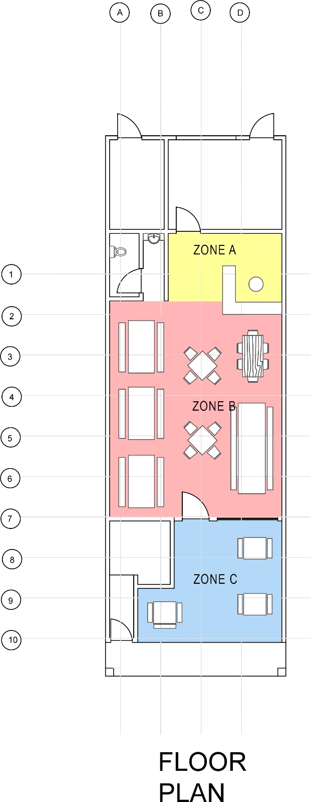

Figure 2.4.5.1 : Floor plan with designated zones

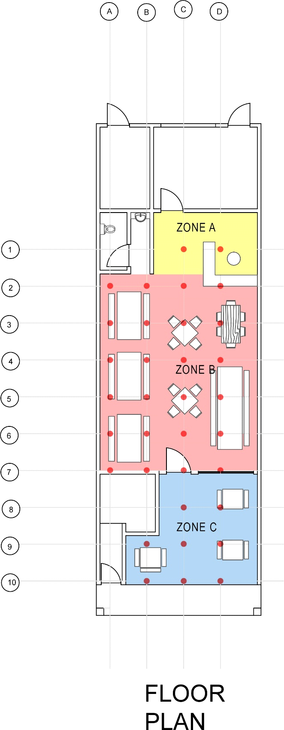
Figure 2.4.5.2 : Floor plan with designated intersection points

The area is divided into three zones which are labelled as zone A, zone B and zone C. Zone A is the counter area where the counter and the entrance to the kitchen is located. Zone B is the dining area where most of the users are normally presence and zone C is the shaded outdoor smoking area. There is a total of two intersection points in zone A, 24 in zone B and 8 in zone C. Altogether, there are a total of 34 intersection point in this building.

2.5 Existing Light Conditions
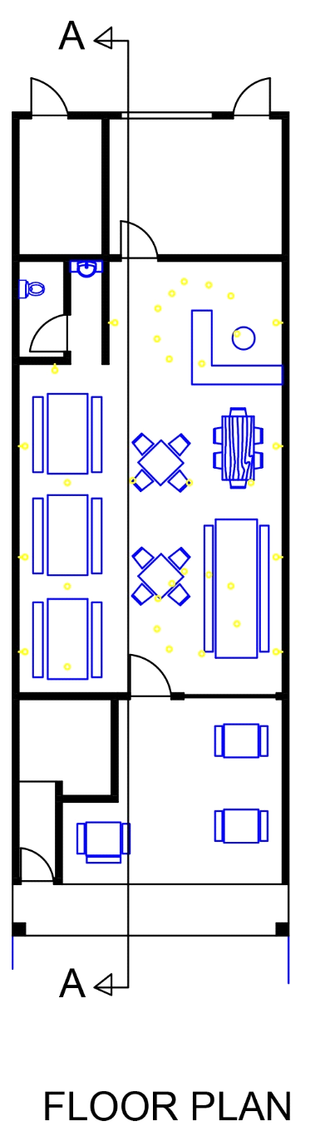

Figure 2.5.1 : Light placement on plan
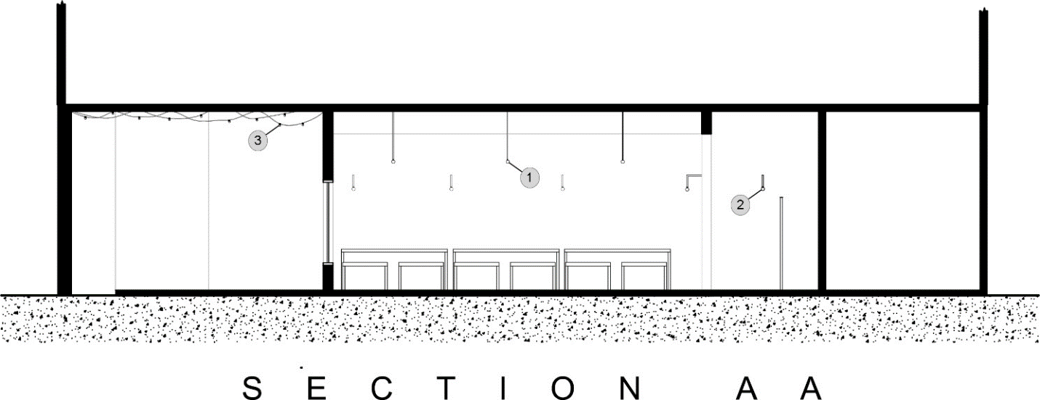
Figure 2.5.2 : Light placement with indication on section

2.5.1 Existing Light Features:

Description + Pictures: | Dimension  (w x l): | Lamp Wattage | CRI | Colour temperature, K | Colour Designation | Lumens, LM | Rated Life, Hrs | Cap - Base
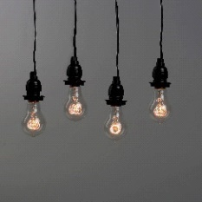1. Coney Island A19 Vintage Bulb | 60mm x 110mm | 40W | 95 | 2200k | Warm white | 160 | 2000 | E26
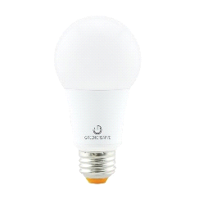2. Green Creative A19 Bulb | 60mm x 110mm | 60W | 92 | 2700k | Warm white | 800 | 2500 | E26
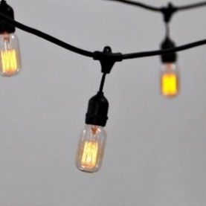3. Heavy Duty 10 – Socket Vintage Light Strand | 457.2mm x 609.6mm | 40W | 95 | 2200k | Warm white | 160 | 2000 | E26
Table 2.5.1.1 : Light Specification

2.5.2 Materials

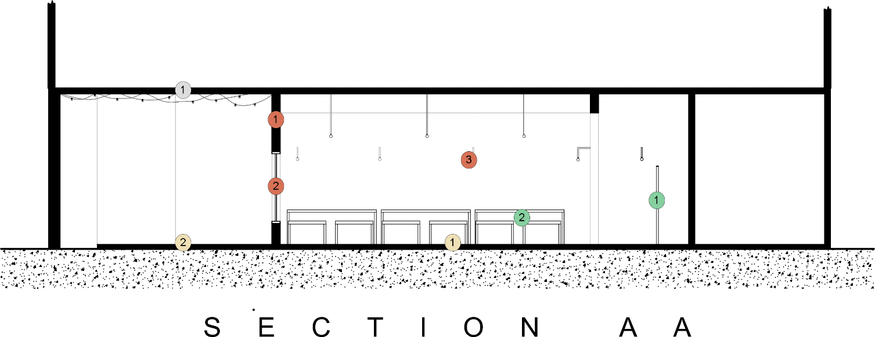
Figure 2.5.2.1 : Material placement with indication on section

1. CEILING
Indicator | Materials | Colour | Reflectance | Surface
1 | Concrete ceiling with purple paint finish  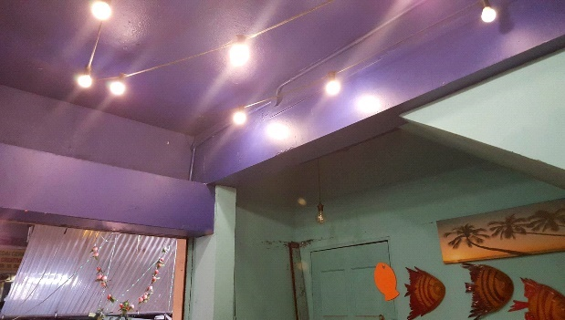 | Purple | 24 | Semi - rough
Table 2.5.2.2 : Ceiling material
2. WALL
Indicator | Materials | Colour | Reflectance | Surface
1 | Timber panels  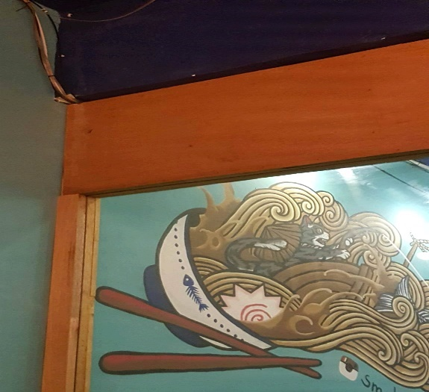 | Orange - brown | 42 | Smooth
2 | Glass  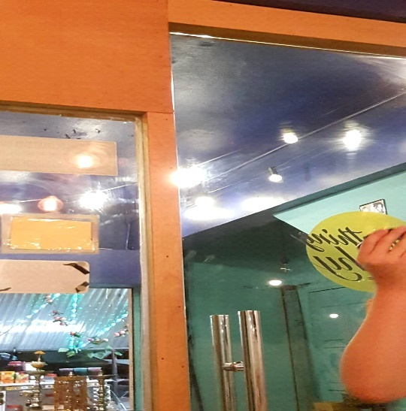 | Transparent | 100 | Smooth
3 | Concrete wall painted with cyan paint finish  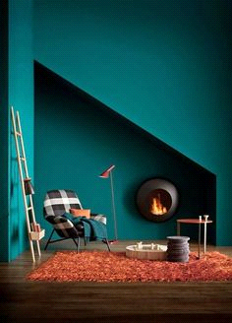 | Cyan | 38 | Smooth
Table 2.5.2.3 Wall material
3. FURNITURES
Indicator | Materials | Colour | Reflectance | Surface
1 | Timber based partition  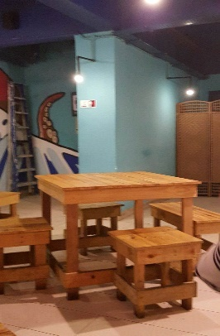 | Dark brown | 19 | Smooth
2 | Timber made table and chairs  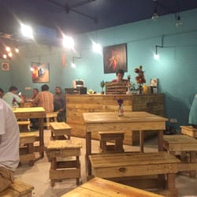 | Light brown | 55 | Smooth
Table 2.5.2.4 : Furniture material
4. FLOOR
Indicator | Material | Colour | Reflectance | Surface
1 | White tiles  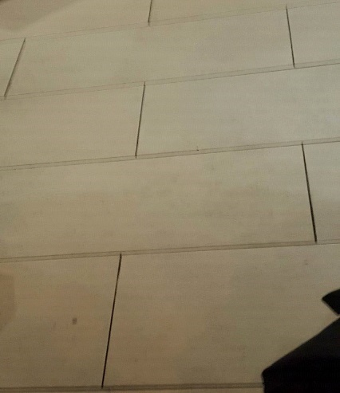 | White | 75 | Semi - rough
2 | Raw concrete  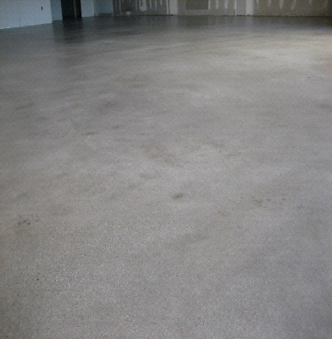 | Dark grey | 18 | Semi - rough
Table 2.5.2.5 : Floor material

2.6 Light Data Analysis
2.6.1 Daytime Lux Reading

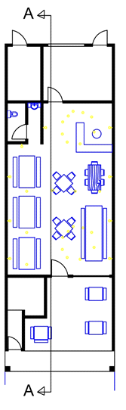

Figure 2.6.1.1 : Floor Plan
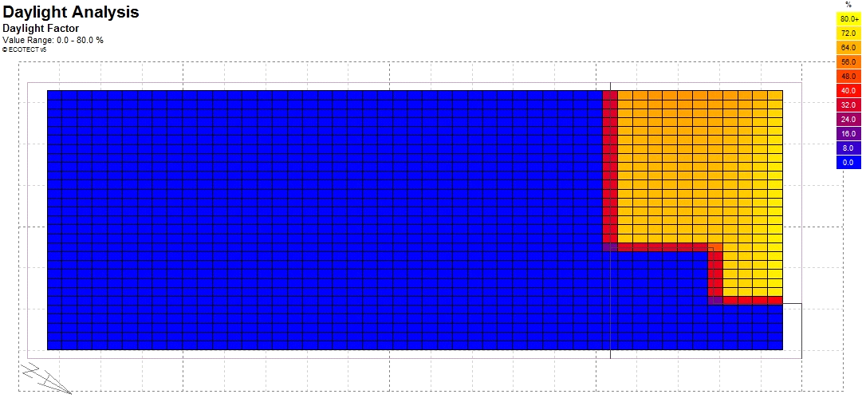
Figure 2.6.1.2 :
Daytime Light contour plan (2nd November 2016: 10a.m.)
(Created using Autodesk Ecotect Analysis)

Due to the type and design of the building the daylight contour plan remains same mostly throughout the day. As shown from the above contour plan, the walk-in eatery area receives most of the daylight as it is open to the street without any barriers. Therefore, the artificial lights in that area are switched off during daytime. However, almost no daylight reaches the interior of the restaurant and needs artificial light to light up the place.

2.6.2 Night Time Lux Reading

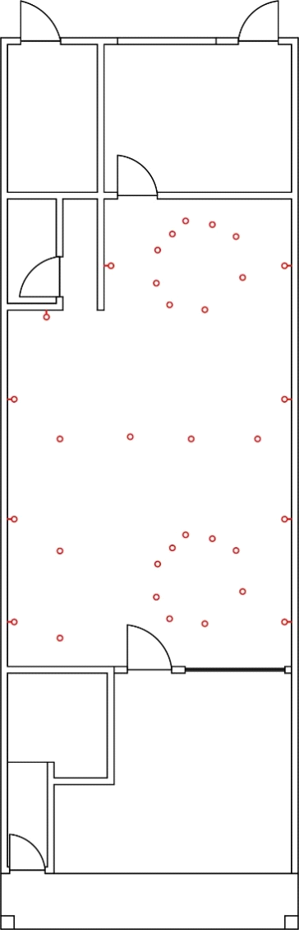

Figure 2.6.1.3 : Floor Plan with indication of artificial lights

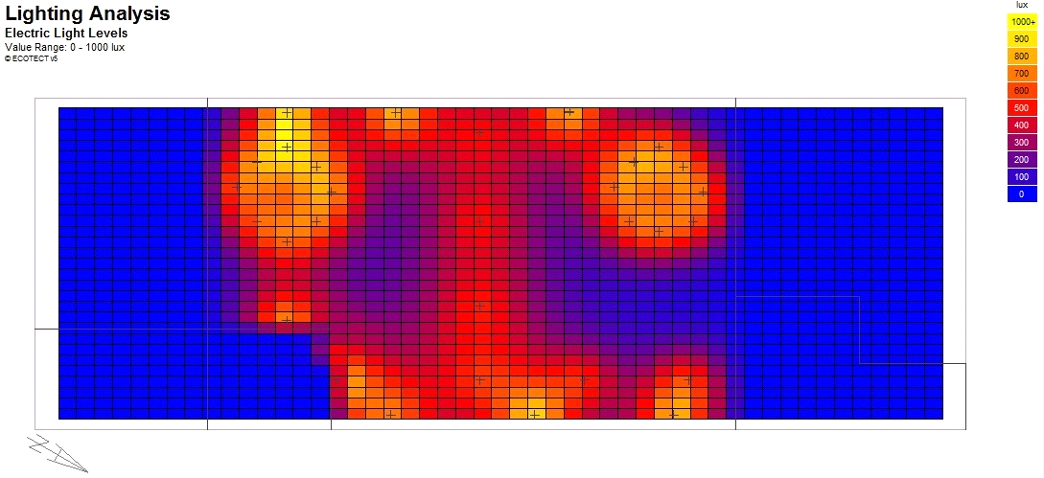
Figure 2.6.1.4 :
Night time contour plan (2nd November 2016: 6p.m.)
(Created using Autodesk Ecotect Analysis)

Most of the lights are placed nearby the seats and tables which eventually makes it suitable for eating restaurant. Lights of different lumens are used within the restaurant to provide different intensities for the areas.

2.7 Lighting Calculation Analysis

2.7.1 Daylight Factor Analysis

ZONE A (COUNTER AREA)

Time | Weather | Luminance at 1m (1x) | Average (1x) | Luminance at  1.5m (1x) | Average (1x)
10 a.m. – 12 p.m. | Clear Sky | 64 – 136 | 100 lux | 43 – 122 | 82.5 lux

Table 2.7.1.1 : Lux reading at Zone A

Average lux reading | 10 a.m. – 12 p.m.
1m | 100
1.5m | 82.5
Average lux value | 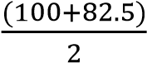 = 91.25 lux (91 lux)

Table 2.7.1.2 : Average lux value at Zone A

Luminance level | Example
120,000 lux | Brightest sunlight
110,000 lux | Bright sunlight
20,000 lux | Shade illuminated by entire clear blue sky, midday
1000 – 2000 lux | Typical over cast day, midday
400 lux | Sunrise or sunset on clear day (ambient illumination)
< 200 lux | Extreme of darkest storm clouds, midday
40 lux | Fully overcast, sunset/sunrise
< 1 lux | Extreme of darkest storm cloud, sunset/sunrise

Table 2.7.1.3 Daylight intensity at different condition

Date and time | 10 a.m. – 12 p.m.
Average lux reading (E internal, Ei) | 91 lux
Daylight factor calculation formula | E𝑖  D = ×100%  E𝑜
Standard direct sunlight (E external, Eo) | 20, 000 lux
Calculation | D = 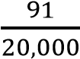 ×100%  = 0.46%

Table 2.7.1.4 : Calculation for daylight factor in Zone A

Daylight factor, DF (%) | Distribution
> 6 | Very bright with thermal and glare problem
3 – 6 | Bright
1 – 3 | Average
0 – 1 | Dark

Table 2.7.1.5 : Daylight factor, DF

The daylight factor at Zone A which is the counter area is rather low. The calculation shown in table x.x shown that it has a daylight factor of 0.46 and it is located in the dark range of the daylight factor table provide in MS 1525. This is due to the lack of opening as it is a shop lot with a linear entry and neighbouring building. Although it is relatively dark in zone A, but it helps to keep the indoor temperature low and also help reduce direct sun exposure into the space.

ZONE B (DINING AREA)

Time | Weather | Luminance at 1m (1x) | Average (1x) | Luminance at  1.5m (1x) | Average (1x)
10 a.m. – 12 p.m. | Clear Sky | 126 – 380 | 253 lux | 128 – 283 | 205.5 lux

Table 2.7.1.6 : Lux reading at Zone B

Average lux reading | 10 a.m. – 12 p.m.
1m | 253
1.5m | 205.5
Average lux value | 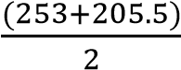 = 229.25 lux (229 lux)

Table 2.7.1.7 : Average lux value at Zone B

Luminance level | Example
120,000 lux | Brightest sunlight
110,000 lux | Bright sunlight
20,000 lux | Shade illuminated by entire clear blue sky, midday
1000 – 2000 lux | Typical over cast day, midday
400 lux | Sunrise or sunset on clear day (ambient illumination)
< 200 lux | Extreme of darkest storm clouds, midday
40 lux | Fully overcast, sunset/sunrise
< 1 lux | Extreme of darkest storm cloud, sunset/sunrise

Table 2.7.1.8 : Daylight intensity at different condition

Date and time | 10 a.m. – 12 p.m.
Average lux reading (E internal, Ei) | 229 lux
Daylight factor calculation formula | E𝑖  D = ×100%  E𝑜
Standard direct sunlight (E external, Eo) | 20, 000 lux
Calculation | D = 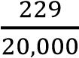 ×100%  = 1.15%

Table 2.7.1.9 : Calculation for daylight factor in Zone B

Daylight factor, DF (%) | Distribution
> 6 | Very bright with thermal and glare problem
3 – 6 | Bright
1 – 3 | Average
0 – 1 | Dark

Table 2.7.2.0 Daylight factor, DF

The daylight factor at the dining area, which is zone B, has a moderately high result as compared to zone A. The calculation shown is 1.15% which puts zone B in the average range in the MS 1525 table. The presence of the glass around the area had led a huge amount of lux to enter into the interior space. This in result could help integrate energy saving during the day, as a few amounts of artificial lights are needed. However, this can cause a few disadvantages. Firstly, is the sun glare which is unavoidable as the reflectance of the exterior material surface alongside the glass allows it to enter. It is advisable that a sun shading device is needed such as thin layer of curtain or a colour tinted glass to be used for this building.

ZONE C (SMOKING AREA)

Time | Weather | Luminance at 1m (1x) | Average (1x) | Luminance at  1.5m (1x) | Average (1x)
10 a.m. – 12 p.m. | Clear Sky | 299 – 465 | 382 lux | 113 – 341 | 227 lux

Table 2.7.2.1 Lux reading at Zone C

Average lux reading | 10 a.m. – 12 p.m.
1m | 382
1.5m | 227
Average lux value | 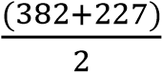 = 304.5 lux

Table 2.7.2.2 Average lux value at Zone C

Luminance level | Example
120,000 lux | Brightest sunlight
110,000 lux | Bright sunlight
20,000 lux | Shade illuminated by entire clear blue sky, midday
1000 – 2000 lux | Typical over cast day, midday
400 lux | Sunrise or sunset on clear day (ambient illumination)
< 200 lux | Extreme of darkest storm clouds, midday
40 lux | Fully overcast, sunset/sunrise
< 1 lux | Extreme of darkest storm cloud, sunset/sunrise

Table 2.7.2.3 Daylight intensity at different condition

Date and time | 10 a.m. – 12 p.m.
Average lux reading (E internal, Ei) | 304.5 lux
Daylight factor calculation formula | E𝑖  D = ×100%  E𝑜
Standard direct sunlight (E external, Eo) | 20, 000 lux
Calculation | D = 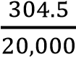 ×100%  = 1.52%

Table 2.7.2.4 : Calculation for daylight factor in Zone C

Daylight factor, DF (%) | Distribution
> 6 | Very bright with thermal and glare problem
3 – 6 | Bright
1 – 3 | Average
0 – 1 | Dark

Table 2.7.2.5 : Daylight factor, DF

The daylight factor for zone C is considerably higher than the other zones. The calculation shown that it has a total of 1.52% in result which also puts it in the average range similarly to zone B in the MS 1525 table. This is due to the reason that it is a partially open space which is located near the entrance of the shop. Thus, this allows a huge amount of lux to brighten up the place during the daytime.

2.7.2 Artificial Lighting Analysis

ZONE A (COUNTER AREA)

Room dimension (m) | 4.23 × 3.00
Floor area (m²) | 12.69
Standard illuminance (lux) | 200
Type of lighting fixture | A19 E26 Bulb (60 W) | A19 E26 Bulb (40W)
Number of lighting fixture | 2 | 9
Lumen of lighting fixture, F (Lm) | 800 | 160
Height of work level (m) meja | 0.70 | 0.70
Height of luminaire (m) light to ground | 2.80 | 3.00
Mounting height (m) | 2.10 | 2.30
Reflection factors | Ceiling: 24.0  Wall: 38.0  Floor: 75.0 | Ceiling: 24.0  Wall: 38.0  Floor: 75.0
Room index, RI (K) formula | 𝐿 ×𝑊  𝑅𝐼 = 𝐻 × (𝐿 + 𝑊)
Room index, RI (K) | 𝑅𝐼 =  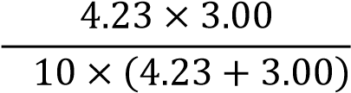  2.  = 0.86 | 𝑅𝐼 =  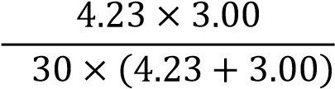  2.  = 0.76
Utilization factor, UF | 0.43 | 0.43
Maintenance factor, MF | 0.8 | 0.8
Illuminance level, E (lux) formula | 𝑁 × 𝐹 × 𝑈𝐹 ×𝑀𝐹  𝐸 =  𝐴
Illuminance level, E (lux) | 𝐸 = 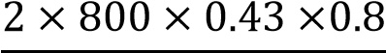  12.69 = 43.37 | 𝐸 =  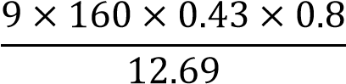  = 39.04
Illuminance level required (lux) | 300 – 43.37 = 256.63  *according to MS 1525, the area lacks of 256.63 lux* | 300 – 39.04 = 260.96  *according to MS 1525, the area lacks of 260.96 lux*
Number of light required formula | 𝐸 ×𝐴  𝑁 =  𝐹 × 𝑈𝐹 × 𝑀𝐹
Number of light required | 𝑁 =  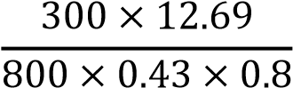  N = 13.8 (14)  14 – 2 = 12 lamps  *in order to achieve MS1525 standards, zone A requires 12  more lamps* | 𝑁 =  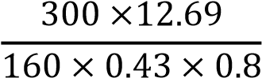  N = 69.2 (70)  70 – 9 = 61 lamps  *in order to achieve  MS1525 standards, zone A requires 61 more lamps*

ZONE B (DINING AREA)

Room dimension (m) | 7.5 × 6.4
Floor area (m²) | 48
Standard illuminance (lux) | 200
Type of lighting fixture | A19 E26 Bulb (60 W) | A19 E26 Bulb (40W)
Number of lighting fixture | 6 | 15
Lumen of lighting fixture, F (Lm) | 800 | 160
Height of work level (m) meja | 0.70 | 0.70
Height of luminaire (m) light to ground | 2.80 | 3.00
Mounting height (m) | 2.10 | 2.30
Reflection factors | Ceiling: 24.0  Wall: 38.0  Floor: 75.0 | Ceiling: 24.0  Wall: 38.0  Floor: 75.0
Room index, RI (K) formula | 𝐿 ×𝑊  𝑅𝐼 = 𝐻 × (𝐿 + 𝑊)
Room index, RI (K) | 𝑅𝐼 =  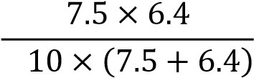  2.  = 1.64 | 𝑅𝐼 =  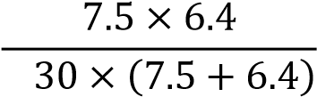  2.  = 1.50
Utilization factor, UF | 0.57 | 0.57
Maintenance factor, MF | 0.8 | 0.8
Illuminance level, E (lux) formula | 𝑁 × 𝐹 × 𝑈𝐹 ×𝑀𝐹  𝐸 =  𝐴
Illuminance level, E (lux) | 𝐸 =  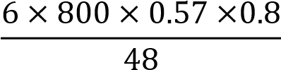  = 45.6 | 𝐸 =  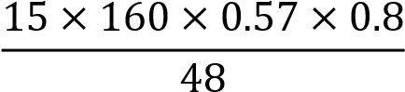  = 22.8
Illuminance level required (lux) | 300 – 45.6 = 254.4  *according to MS 1525, the area lacks of 254.4 lux* | 300 – 22.8 = 277.2  *according to MS 1525, the area lacks of 277.2 lux*
Number of light required formula | 𝐸 ×𝐴  𝑁 =  𝐹 × 𝑈𝐹 × 𝑀𝐹
Number of light required | 𝑁 =  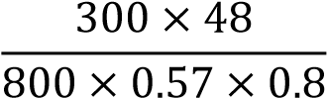  N = 39.4 (39)  39 – 6 = 33 lamps  *in order to achieve MS1525 standards, zone A requires 33  more lamps* | 𝑁 =  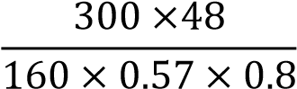  N = 197.3 (197)  197 – 15 = 182 lamps  *in order to achieve MS1525 standards, zone A requires 182 more lamps*

ZONE C (SMOKING AREA)

Room dimension (m) | (4 × 2.5) + (5.4 × 2)
Floor area (m²) | 20.8
Standard illuminance (lux) | 200
Type of lighting fixture | E26 Socket Light (40W)
Number of lighting fixture | 20
Lumen of lighting fixture, F (Lm) | 160
Height of work level (m) meja | 0.70
Height of luminaire (m) light to ground | 2.80
Mounting height (m) | 2.10
Reflection factors | Ceiling: 24.0  Wall: 38.0  Floor: 18.0
Room index, RI (K) formula | 𝐿 ×𝑊  𝑅𝐼 = 𝐻 × (𝐿 + 𝑊)
Room index, RI (K) | 𝑅𝐼 =  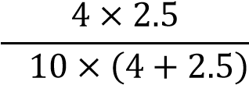  2.  = 0.7  𝑅𝐼 =  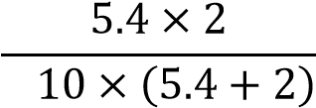  2.  = 0.69 (0.7)
Average Room Index, RI (K) | 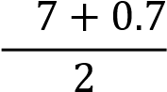  0.  = 0.7
Utilization factor, UF | 0.43
Maintenance factor, MF | 0.8
Illuminance level, E (lux) formula | 𝑁 × 𝐹 × 𝑈𝐹 ×𝑀𝐹  𝐸 =  𝐴
Illuminance level, E (lux) | 𝐸 = 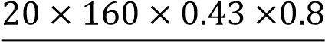  20.8 = 52.92
Illuminance level required (lux) | 300 – 52.92 = 247.07  *according to MS 1525, the area lacks of 247.07 lux*
Number of light required formula | 𝐸 ×𝐴  𝑁 =  𝐹 × 𝑈𝐹 × 𝑀𝐹
Number of light required | 𝑁 =  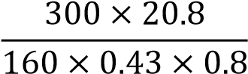  N = 113.4 (113)  113 – 20 = 93 lamps  *in order to achieve MS1525 standards, zone A requires 93 more lamps*

2.8 Conclusion

Relatively, the natural lighting in Something Fishy SS15 is good based on the daylight factor calculation which ranges mostly around average. The sufficient of daylighting is mostly influence by the provided openings. This became the necessary component for the shop in order to create a certain mood or atmosphere based on its theme.
Aside from that, based on our observation, we have found out that Something Fishy has few lights in the dining area and at the counter area. It is observed that these three zones have different values of illumination during the day and also at night. During the day, the light from the sun enters the building through the glass materials in the dining area without the need of using any artificial light. As of night time however, all three areas are lighted up with low artificial lightings. However due to the low lumens value that each bulb of the artificial lighting has, there is not enough light to fully brighten up the space in the building as required by MS 1525 standard. This can be improved by adding more lights into the building. As the required number of lights calculated may seem to be too much to be fitted into the building, another option that can be recommended is to replace the existing lights in the building with much stronger ones. Hence, it can provide better visualization for the occupants.
In conclusion, the quality of lighting of the building especially in the dining and counter area is insufficient during the day. These spaces need to improve by adding more openings or change the colour of the surface to a much brighter colour instead of a dark colour so that it would help in reflecting the light ray rather than absorbing it.

3.0
ACOUSTIC PERFORMANCE EVALUATION

  - Literature Review

3.1.1 Architectural Acoustic
Acoustics is the study of all mechanical waves in gases, liquids and solids. Which are categorized under the topic such as vibration, ultrasound, infrasound and sound. Architectural acoustic also known as room or building acoustic is the science and engineering of achieving optimum sound levels within a building. The aim is to provide a building with a desired sound levels that is optimum for all around spaces within the building whilst also eliminating or reducing any sound that interrupts with the ongoing activities, this is also known as noise.

3.1.2 Sound Pressure Level (SPL)
Sound pressure level is actually a ratio of the absolute, sound pressure and a reference level. Level this is usually the threshold of hearing from the lowest intensity sound that can be heard by most people. Sound pressure level is usually measured in decibels (dB), because of the incredibly broad range of intensity levels we could hear. Below are the typical sound levels which ranges from an optimum and extreme level of pressure to be heard.
Sources at 1 m | Sound Pressure | Lp re 20 µPa *
Rifle | 200 Pa | 140 dB
Threshold of pain | 20 Pa | 120 dB
Pneumatic hammer | 2 Pa | 100 dB
6 dB = double the Pa | 1 Pa | 94 dB
Street traffic | 0.2 Pa | 80 dB
Talking | 0.02 Pa | 60 dB
Library | 0.002 Pa | 40 dB
TV Studio | 0.0002 Pa | 20 dB
Threshold of hearing | 0.00002 Pa | 0 dB

Calculation for sound pressure level (SPL)
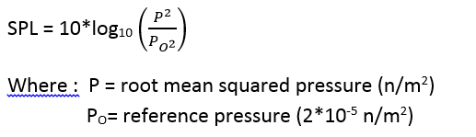

3.1.3 Reverberation Time (RT)
Reverberation is the collection of reflected sounds from the surface of an enclosure such as rooms where the sound source is turned off. Reverberation time however is defined as the length of time required for a sound to decay 60 decibels from its initial level.

Calculation for reverberation time (RT)
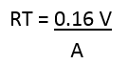

Where : RT – reverberation time (sec)
V – volume of the room
A – total absorption of room surfaces

3.1.4 Sound Reduction Index (SRI)
Sound reduction index or transmission loss of a partition measures the number of decibels lost when a sound of a given frequency is transmitted through the partition.
Calculation for sound reduction index (SRI)

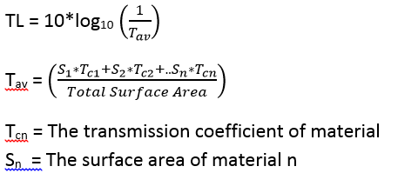

  - Precedent Studies

3.2.1 Introduction
Cork School of Music, Union Quay
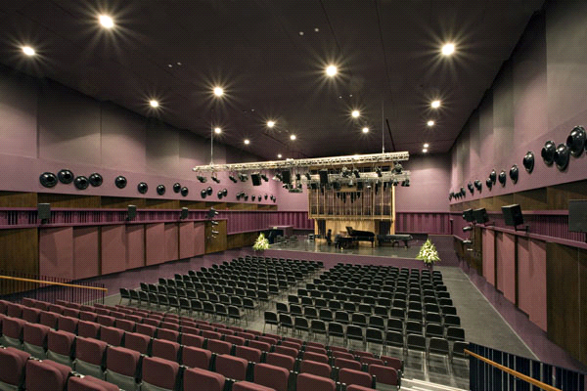
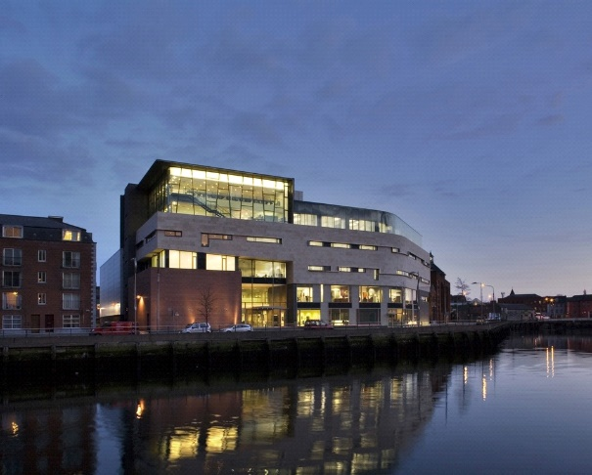

Figure X.X.X : Façade of the Cork School of Music Figure X.X.X : Curtis Auditorium inside the building

The Cork School of Music which is under its main facility the Cork Institute of Technology is located in the centre of Cork City, Ireland. It was founded in the year 1878 and became a school of Cork Institute of Technology in 1993. It is operating from a five – floor music centre which was built on the site of the former premises with an area approaching 13,000m². Opened in 2007, the school of music was designed by Murray O’Laoire and Buro Happold.
The main goal of this building is to cater for the students and staff which enrolls in the field of music and drama. Suitable spaces to execute these studies must be in par and follow the requirements of an optimum acoustics space. The Cork School of Music facilitates different spaces which are according to their specific functions. Spaces such as the Curtis auditorium, stack theatre, recording suite (control room), recording suite (live room), teaching studios, ground floor concourse and library are located in this school to be used for their daily routine.
Variable acoustic elements could be found in the Curtis auditorium to provide for a more flexible activities ranging from a small ensemble rehearsal through a performance of a 500 – seat audience. Features such as movable ceiling that can be raised higher and lower to allow for the changes of volume to be taken by up to 40% are included. As well as diffusing panels and variable wall panels delivering flexible acoustic element.

Space | Fabric Sound  Insulation | External Noise  Intrusion Limit | Mechanical Services Noise Level Limit | Mid-Frequency  Reverberation Time
Rehearsal Hall | R’_{w} 70dB | L_{A10} 20 dB | NR 20 | 1.2s to 1.8s
Black Box Theatre | R’_{w} 65 dB | L_{A10} 20 dB | NR 25 | 0.8s
Movement Room | R’_{w} 55 dB | L_{A10} 30 dB | NR 30 | 1.2s
Tuition Rooms | R’_{w} 70 dB | L_{A10} 25 dB | NR 25 | 1.0s
Percussion Studio | R’_{w} 70 dB | L_{A10} 25 dB | NR 25 | 0.7s
Double Bass Studio | R’_{w} 70 dB | L_{A10} 25 dB | NR 25 | 1.0s
Organ Room | R’_{w} 70 dB | L_{A10} 25 dB | NR 25 | 1.0s
Lecture Theatres | R’_{w} 55 dB | L_{A10} 25 dB | NR 30 | 0.8s
Music/IT Labs | R’_{w} 45 dB | L_{A10} 30 dB | NR 35 | 0.8s
Electronic Music Centre | R’_{w} 55 dB | L_{A10} 30 dB | NR 30 | 0.8s
Recording Studio  - Live room  - Control Room  - -Edit Suite | R’_{w} 70 dB  R’_{w} 65 dB  R’_{w} 65 dB | L_{A10} 15 dB  L_{A10} 20 dB  L_{A10} 20 dB | NR 15  NR 20  NR 20 | 1.0s  0.4s  0.4s
Offices | R’_{w} 35 dB | L_{A10} 35 dB | NR 38 | n/a
Boardroom | R’_{w} 45 dB | L_{A10} 35 dB | NR 30 | n/a
Figure 3.2.1.1 Technical overview of the spaces in the Cork School of Music

3.2.2 Conclusion
To conclude building such as Cork School of Music which host spaces that need an optimum acoustics and suitable sound proofing needed to be taking into consideration such as the material used. A lot in these spaces utilize the building material as well as the finishing material to enable for decent sound levels such as the fabric sound insulation which is used a lot to maintain the echo and any sound leaking. Thus wall panels and finishing material have an effect on controlling the sound level coming from and out of the spaces.

  - Research Methodology

3.3.1 Acoustic Measuring Equipment
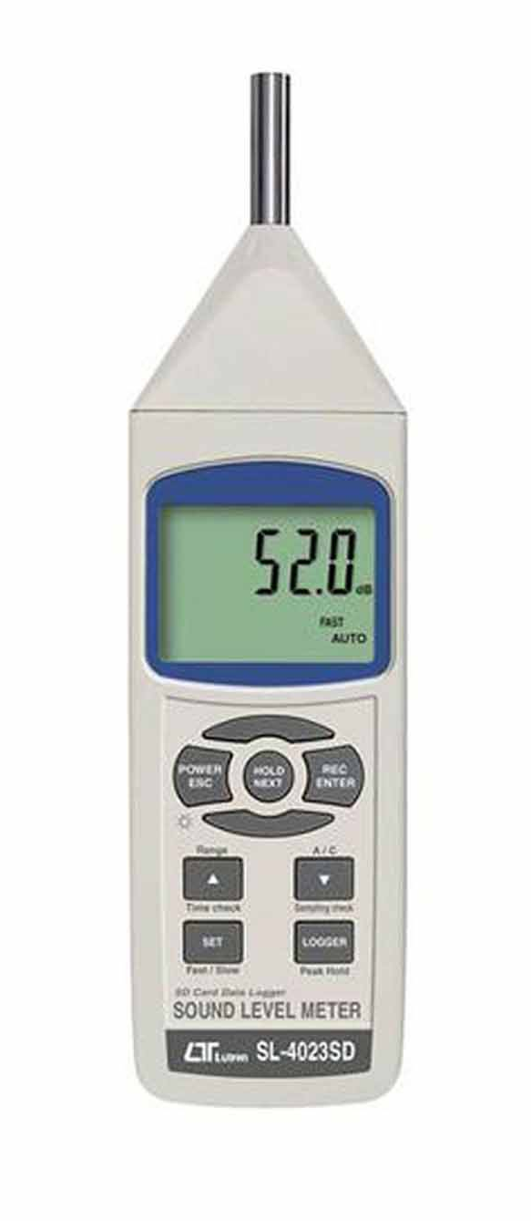

Sound Level Meter
A hand held equipment with a microphone that responds to the changes in air pressure caused by sound waves.
Specification
Manufacturer | LUTRON Lighting
Model | SL – 4023 SD
Dimension/Weight | 245 x 68 x 45 mm / 489 g – battery
Range | 30 – 130 Db
Linearity | + 1.5 Db

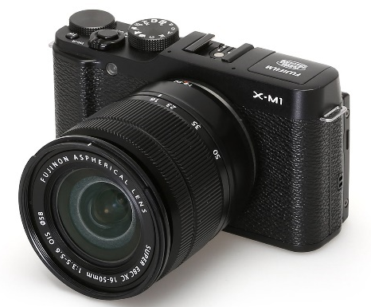
Digital Camera
Used to record and document source of noise such as human activities, mechanical devices, etc. Also used to capture materials and texture that affects the acoustics of the space.

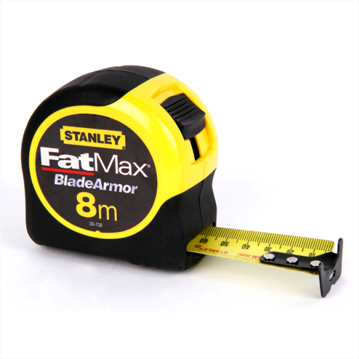

Measuring Tape
Used to measure the 1.5m x 1.5m grid lines of the site and the sound level sources from ground level.

3.3.2 Methodology

- Preliminary studies were conducted to choose the suitable enclosed space as our case study.
- Approval from the management of the site is obtained and meetings are arranged to conduct studies.
- The entire site was measured using a 1.5m x 1.5m grid line and technical drawings were produced to aid studies.
- Tasks among members were distributed to ease research process on site.
- Noise level during peak and non-peak hours were recorded using the sound level meter.
- Sources of noise such as human activities, mechanical devices, etc are recorded using the digital camera.
- Types of textures and materials are recorded using the digital camera.
- Compile and tabulate the data collected.
- Calculation and analysis are carried out and a conclusion was driven from the study.

3.3.3 Data Collection Procedure

- A grid line of 1.5m x 1.5m were drawn and plotted on the floor plan to determine the point of data collection
- Measurements and recordings are taken at the points of intersection of the grid lines at 1m above ground level.
- Sources of noise are observed and recorded that affects the reading.
- Steps 2-3 are repeated at all of the intersection points.
- Recordings are repeated at two times ; peak hours (12.00 am) and non-peak hours (7.00 pm)
- Analyze the difference between the recordings of these two time period.
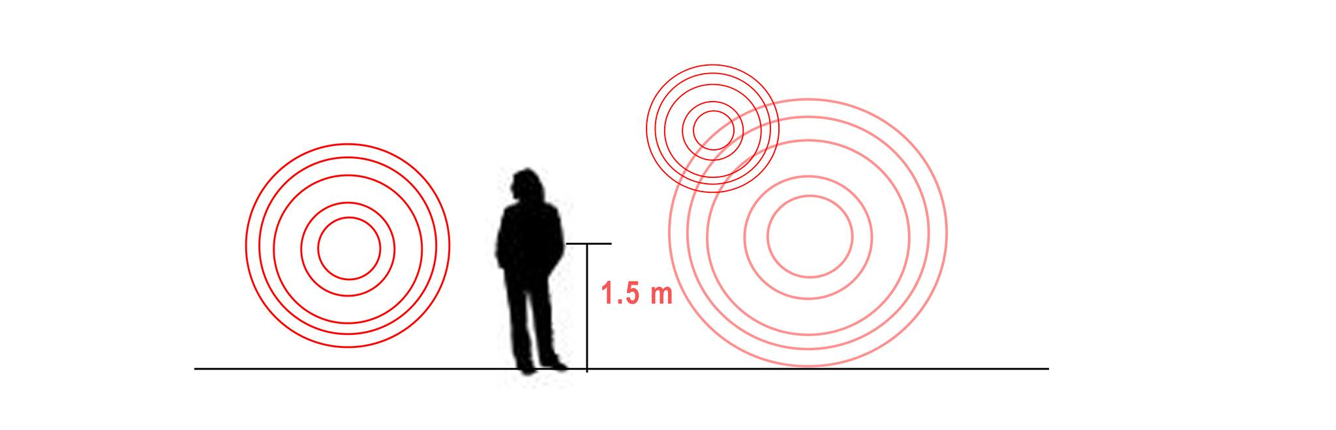

Figure 3.3.3.1 : Noise is recorded 1.5 m from ground level
Figure 3.3.3.2 : Floor plan with designated intersection points

The area is divided into three zones which are labelled as zone A, zone B and zone C. Zone A is the counter area where the counter and the entrance to the kitchen is located. Zone B is the dining area where most of the users are normally presence and zone C is the shaded outdoor smoking area. There is a total of two intersection points in zone A, 24 in zone B and 8 in zone C. Altogether, there are a total of 34 intersection point in this building.

3.4 Case Study
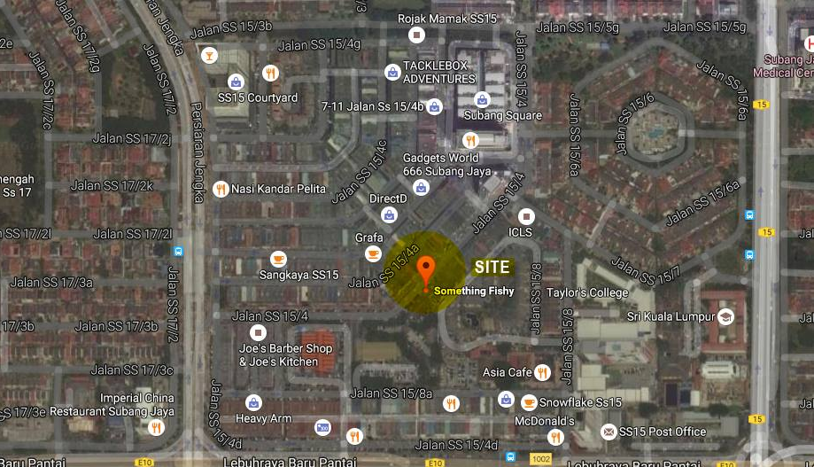

Figure 3.4.1 : Site Location
Something Fishy is located alongside numerous other cafes and restaurants that results in it being a popular hotspot. It is situated along a row of shoplots which houses multiple types of commercial activities – mostly eateries.

3.5 Existing Noise Sources

As the café is positioned at a prime location, noise sources can be detected mainly from the surrounding cafes in the neighbourhood, as most of it facilitates outdoor seating areas. Besides that, the traffic in front of the café is also usually congested therefore causing a moderate amount of noise coming into the café

3.5.1 External Noise
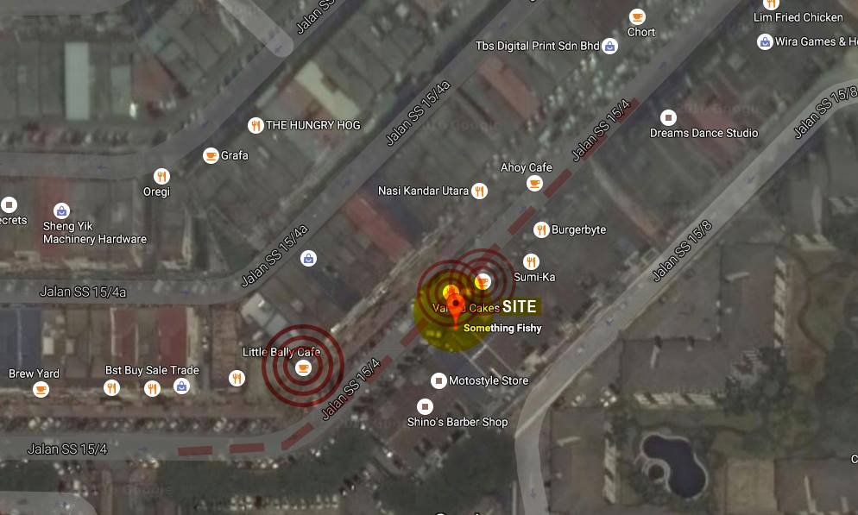

Neighboring Cafes
Surrounding the site is a highly concentrated group of active cafes and restaurants. Outdoor seating areas, speakers of music blasting and LCD screens causes noise from human activities.

Traffic
Traffic in front of the site is usually highly congested, as it is one of the main access roads to a number of colleges located nearby. Rush hours are usually between 7-9 am, 12 pm and 6-8 pm.

3.5.2 Internal Noise

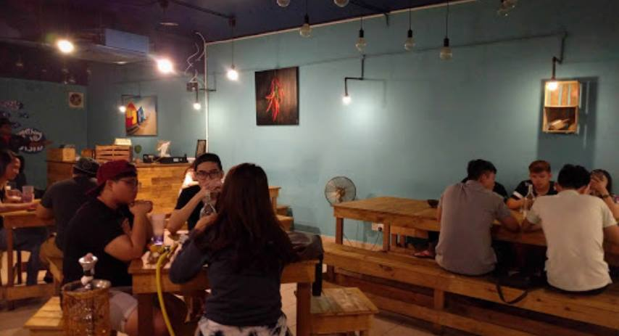
Human Activities

Figure 3.5.2.1 : human activities
The main noise sources of the human activities are from conversations, laughter and socializing. As most of the customers of the café comes in groups, the source of noises are high especially during peak hours. Noise sources mainly come from Zone A, and B.

Speakers
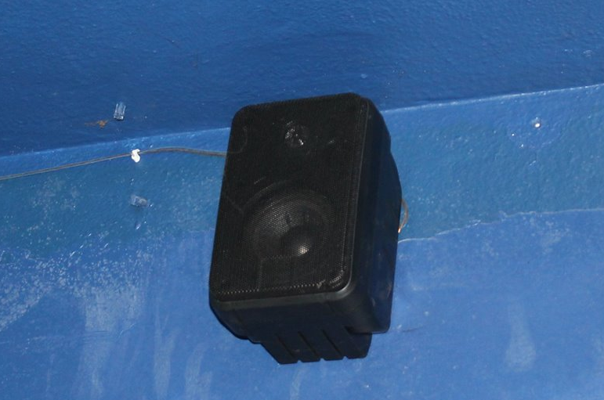

Figure 3.5.2.2 : wall mounted speaker
Music is constantly blasting from the speakers throughout the café. Speakers are positioned both indoors and outdoors.

Fans
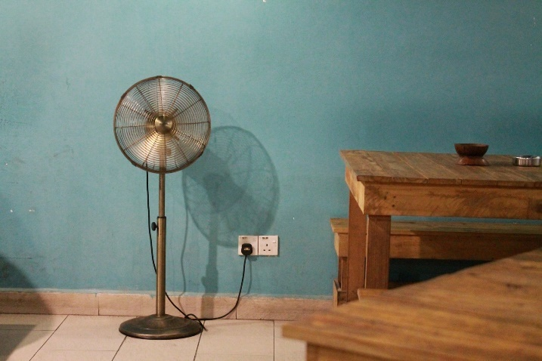

Figure 3.5.2.3 : stand alone fan

Additional portable fans are needed to ventilate and cool the space down as it allows smoking indoors. The noise from the fan is quite noticeable as it is positioned near the seating areas.

3.5.3 Location of Noise Source

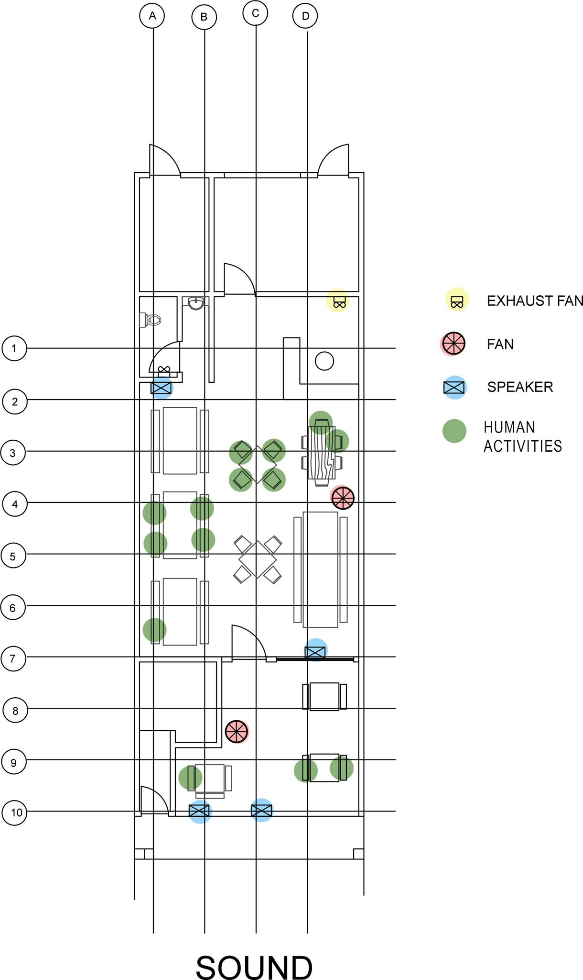

Figure 3.5.3.1 : Location of noise sources mapped out on plan

The speakers at the café acts as one of the primary noise source as it is positioned throughout the building. With the music constantly blasting, the entire café can experience the noise coming from it. Besides that, human activities is also one of its main sources. The nature of the café attracts people in groups/crowds hence resulting in constant high occupancy rate, which contributes to a higher noise level at certain periods of the day.

Source | Specification |  | Unit
- Vent  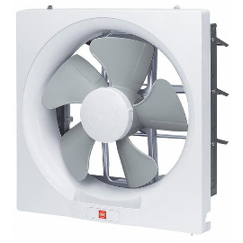 | Product name | KDK 30AQM8 Wall Mount Ventilation Fan | 1
 | Weight | 3 kg | 1
 | Dimension | 6.5 x 39 x 51 | 1
 | Motor Rating | 240 V / 50 Hz | 1
 | Noise Level | 45 Db | 1
 | Placement | Wall | 1
- Fan  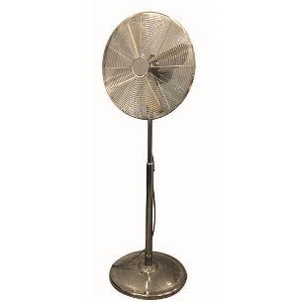 | Product name | KDK KX405 Stand Fan | 2
 | Weight | 8.3 kg | 2
 | Dimension | 49 x 31 x 58 | 2
 | Noise Level | < 60 dB | 2
 | Placement | Floor | 2
- Speaker  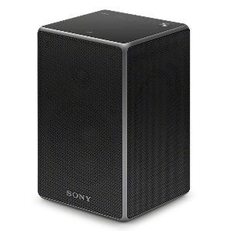 | Product name | Sony Wireless Speaker SRS-ZR5 | 4
 | Weight | 2.3 kg | 4
 | Dimension | 15 x 15 x 21 | 4
 | Frequency Range | 20 - 20k Hz | 4
 | Power Consumption | 30 W (AC) | 4
 | Placement | Wall | 4

Table 3.5.3.2 : Noise sources and specifications

  - Material and Properties

ZONE A ( COUNTER AREA )
Components | Materials | Colour | Surface  Finishes | Absorption Coefficient |  | Area(m2)
 |  |  |  | 500Hz | 2000Hz | 12.80
Wall | Brick | White | Rough | 0.03 | 0.04 | 32.14
Floor Tiles | Plaster | White | Smooth | 0.80 | 0.65 | 12.80
Door | Timber | White | Smooth | 0.15 | 0.10 | 1.89
Ceiling | Concrete | Black | Smooth | 0.05 | 0.05 | 12.80
Counter Table | Timber | Brown | Matte | 0.22 | 0.38 | 1.65
Occupants |  |  |  | 0.46 | 0.51

ZONE B ( DINING AREA )
Components | Materials | Colour | Surface  Finishes | Absorption Coefficient |  | Area(m²)
 |  |  |  | 500Hz | 2000Hz | 48.60
Wall | Brick | White | Smooth | 0.03 | 0.04 | 64.61
 | Glass | Clear | Smooth | 0.10 | 0.05 | 9.46
Floor Tiles | Plaster | White | Smooth | 0.80 | 0.65 | 48.60
Door | Glass | Clear | Smooth | 0.10 | 0.07 | 1.89
Ceiling | Concrete | Black | Smooth | 0.05 | 0.05 | 48.60
Dining Table | Timber | Brown | Matte | 0.15 | 0.10 | 11.46
Chair | Timber | Brown | Matte | 0.10 | 0.12 | 5.46
Occupants |  |  |  | 0.46 | 0.51

ZONE C ( SMOKING AREA )
Components | Materials | Colour | Surface  Finishes | Absorption Coefficient |  | Area(m²)
 |  |  |  | 500Hz | 2000Hz | 19.91
Wall | Brick | White | Smooth | 0.03 | 0.04 | 25.31
 | Glass | Clear | Smooth | 0.10 | 0.05 | 9.46
Floor Tiles | Plaster | White | Smooth | 0.80 | 0.65 | 19.91
Door | Glass | Clear | Smooth | 0.10 | 0.07 | 1.89
Ceiling | Concrete | Black | Smooth | 0.05 | 0.05 | 19.91
Dining Table | Timber | Brown | Matte | 0.15 | 0.10 | 2.02
Chair | Timber | Brown | Matte | 0.10 | 0.12 | 0.90
Occupants |  |  |  | 0.46 | 0.51
  - Acoustic Tabulation Data
Acoustic Readings

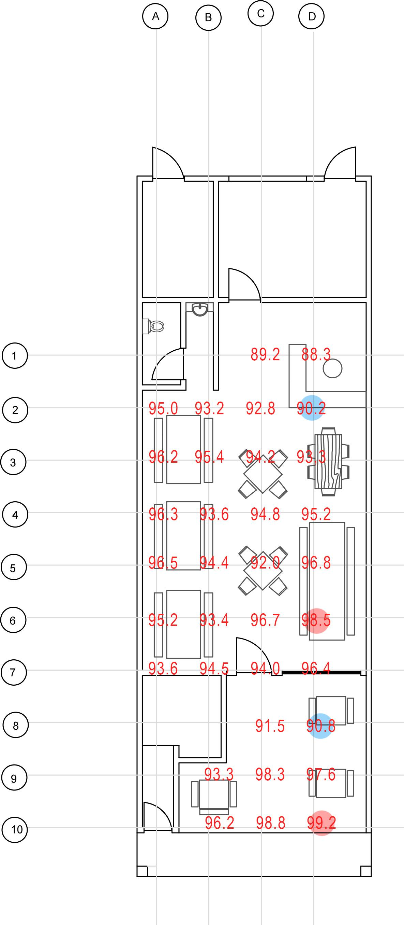

Lowest reading as it is quite isolated from the main eatery area

Highest reading as it is positioned near the speaker, and is a spot reserved for large group of people

Highest reading as it is situated outside and is exposed to external noise sources

Figure 3.7.1.1 : Acoustic reading during peak hour

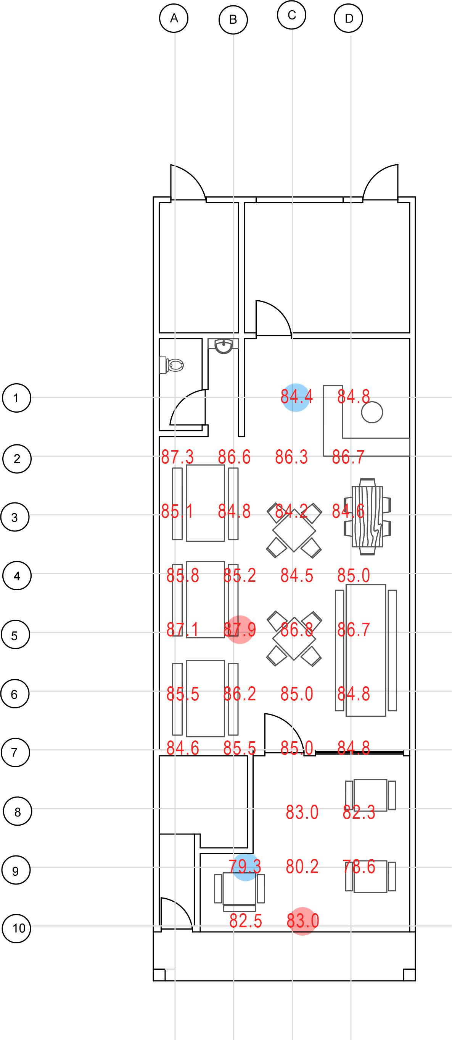

Lowest reading as it is quite isolated from the main eatery area

Highest reading due to a relatively high number of people

Highest reading as it is exposed to external noise sources

Figure 3.7.1.2 Acoustic reading during non-peak hour

PEAK HOUR ( 11.00 pm / 27 occupants )

11:00 | A | B | C | D
1 |  |  | 89.2 | 88.3
2 | 95.0 | 93.2 | 92.8 | 90.2
3 | 96.2 | 95.4 | 94.2 | 93.3
4 | 96.3 | 93.6 | 94.8 | 95.2
5 | 96.5 | 94.4 | 92.0 | 96.8
6 | 95.2 | 93.4 | 96.7 | 98.5
7 | 93.6 | 94.5 | 94.0 | 96.4
8 |  |  | 91.5 | 90.8
9 |  | 93.3 | 98.3 | 97.6
10 |  | 96.2 | 98.8 | 99.2

Table 3.7.1.3 : Acoustic reading during peak hours

NON-PEAK HOUR ( 6.30 pm / 16 occupants )

6:30 | A | B | C | D
1 |  |  | 84.4 | 84.8
2 | 87.3 | 86.6 | 86.3 | 86.7
3 | 85.1 | 84.8 | 84.2 | 84.6
4 | 85.8 | 85.2 | 84.5 | 85.0
5 | 87.1 | 87.9 | 86.8 | 86.7
6 | 85.5 | 86.2 | 85.0 | 84.8
7 | 84.6 | 85.5 | 85.0 | 84.8
8 |  |  | 83.0 | 82.3
9 |  | 79.3 | 80.2 | 78.6
10 |  | 82.5 | 83.0 | 81.5

Table 3.7.1.4 : Acoustic reading during non peak hours

3.7.1 Sound Intensity Level Calculation

ZONE A (COUNTER AREA)
PEAK HOUR
Peak Hour : | 11 pm - 1 am
Highest readings: | 95.0 , 93.2 , 92.8
SIL _{A} = | 10log₁₀ I _{A} |  | SIL _{B} = | 10log₁₀ I _{B} |  | SIL _{C} = | 10log₁₀ I _{C}
 | I _{O} |  |  | I _{O} |  |  | I _{O}
95.0= | 10log₁₀ I _{A} |  | 93.2= | 10log₁₀ I _{B} |  | 92.8= | 10log₁₀ I _{C}
 | 1 x 10 ⁻¹² |  |  | 1 x 10 ⁻¹² |  |  | 1 x 10 ⁻¹²
9.5 = | log I _{A} |  | 9.32 = | log I _{B} |  | 9.28 = | log I _{C}
 | 1 x 10 ⁻¹² |  |  | 1 x 10 ⁻¹² |  |  | 1 x 10 ⁻¹²
10 ^{9.5} = | I _{A} |  | 10 ^{9.32} = | I _{B} |  | 10 ^{9.28} = | I _{C}
 | 1 x 10 ⁻¹² |  |  | 1 x 10 ⁻¹² |  |  | 1 x 10 ⁻¹²
I _{A =} | 10 ^{9.5} x ( 1 x 10 ⁻¹²) |  | I _{B =} | 10 ^{9.32} x ( 1 x 10 ⁻¹²) |  | I _{A =} | 10 ^{9.28} x ( 1 x 10 ⁻¹²)
= | 3.16 x 10 ⁻³ |  | = | 2.09 x 10 ⁻³ |  | = | 1.91 x 10 ⁻³
Total I = | (3.16 x 10 ⁻³ ) + ( 2.09 x 10 ⁻³ ) + ( 1.91 x 10 ⁻³ )
= | 7.16 x 10 ⁻³
SIL = | 10log I
 | I _{O}
= | 10log I
 | 1 x 10 ⁻¹²
= | 10log 7.16 x 10 ⁻³
 | 1 x 10 ⁻¹²
= | 10log 7.16 x 10 ⁹
= | 98.55 dBs | (2d.p)

NON PEAK HOUR
Unpeak Hour : | 6 pm - 8 pm
Highest readings: | 87.3 , 86.7 , 86.6
SIL _{A} = | 10log₁₀ I _{A} |  | SIL _{B} = | 10log₁₀ I _{B} |  | SIL _{C} = | 10log₁₀ I _{C}
 | I _{O} |  |  | I _{O} |  |  | I _{O}
87.3= | 10log₁₀ I _{A} |  | 86.7= | 10log₁₀ I _{B} |  | 86.6= | 10log₁₀ I _{C}
 | 1 x 10 ⁻¹² |  |  | 1 x 10 ⁻¹² |  |  | 1 x 10 ⁻¹²
8.73 = | log I _{A} |  | 8.67 = | log I _{B} |  | 8.66 = | log I _{C}
 | 1 x 10 ⁻¹² |  |  | 1 x 10 ⁻¹² |  |  | 1 x 10 ⁻¹²
10 ^{8.73} = | I _{A} |  | 10 ^{8.67} = | I _{B} |  | 10 ^{8.66} = | I _{C}
 | 1 x 10 ⁻¹² |  |  | 1 x 10 ⁻¹² |  |  | 1 x 10 ⁻¹²
I _{A =} | 10 ^{8.73} x ( 1 x 10 ⁻¹²) |  | I _{B =} | 10 ^{8.67} x ( 1 x 10 ⁻¹²) |  | I _{A =} | 10 ^{8.66} x ( 1 x 10 ⁻¹²)
= | 5.37 x 10 ⁻⁴ |  | = | 4.68 x 10 ⁻⁴ |  | = | 4.57 x 10 ⁻⁴
Total I = | (5.37 x 10 ⁻⁴ ) + ( 4.68 x 10 ⁻⁴ ) + ( 4.57 x 10 ⁻⁴ )
= | 14.617 x 10 ⁻⁴
SIL = | 10log I
 | I _{O}
= | 10log I
 | 1 x 10 ⁻¹²
= | 10log 14.617 x 10 ⁻⁴
 | 1 x 10 ⁻¹²
= | 10log ( 1461700000)
= | 91.65 dBs | (2d.p)

The difference in the sound intensity level between the peak and non - peak period of zone A is 98.55dBs - 91.65dBs = 6.90dBs.

ZONE B (DINING AREA)
PEAK HOUR
Peak Hour : | 11 pm - 1 am
Highest readings: | 98.5 , 96.8 , 96.7
SIL _{A} = | 10log₁₀ I _{A} |  | SIL _{B} = | 10log₁₀ I _{B} |  | SIL _{C} = | 10log₁₀ I _{C}
 | I _{O} |  |  | I _{O} |  |  | I _{O}
98.5= | 10log₁₀ I _{A} |  | 96.8= | 10log₁₀ I _{B} |  | 96.7= | 10log₁₀ I _{C}
 | 1 x 10 ⁻¹² |  |  | 1 x 10 ⁻¹² |  |  | 1 x 10 ⁻¹²
9.85 = | log I _{A} |  | 9.68 = | log I _{B} |  | 9.67 = | log I _{C}
 | 1 x 10 ⁻¹² |  |  | 1 x 10 ⁻¹² |  |  | 1 x 10 ⁻¹²
10 ^{9.85} = | I _{A} |  | 10 ^{9.68} = | I _{B} |  | 10 ^{9.67} = | I _{C}
 | 1 x 10 ⁻¹² |  |  | 1 x 10 ⁻¹² |  |  | 1 x 10 ⁻¹²
I _{A =} | 10 ^{9.85} x ( 1 x 10 ⁻¹²) |  | I _{B =} | 10 ^{9.68} x ( 1 x 10 ⁻¹²) |  | I _{A =} | 10 ^{9.67} x ( 1 x 10 ⁻¹²)
= | 7.08 x 10 ⁻³ |  | = | 4.79 x 10 ⁻³ |  | = | 4.68 x 10 ⁻³
Total I = | (7.08 x 10 ⁻³ ) + ( 4.79 x 10 ⁻³ ) + ( 4.68x 10 ⁻³ )
= | 16.55 x 10 ⁻³
SIL = | 10log I
 | I _{O}
= | 10log I
 | 1 x 10 ⁻¹²
= | 10log 16.55 x 10 ⁻³
 | 1 x 10 ⁻¹²
= | 10log 16.55 x 10 ⁹
= | 102.19 dBs | (2d.p)

NON PEAK HOUR

Unpeak Hour : | 6 pm - 8 pm
Highest readings: | 87.9 , 87.1 , 86.7
SIL _{A} = | 10log₁₀ I _{A} |  | SIL _{B} = | 10log₁₀ I _{B} |  | SIL _{C} = | 10log₁₀ I _{C}
 | I _{O} |  |  | I _{O} |  |  | I _{O}
87.9= | 10log₁₀ I _{A} |  | 87.1= | 10log₁₀ I _{B} |  | 86.7= | 10log₁₀ I _{C}
 | 1 x 10 ⁻¹² |  |  | 1 x 10 ⁻¹² |  |  | 1 x 10 ⁻¹²
8.79 = | log I _{A} |  | 8.71 = | log I _{B} |  | 8.67 = | log I _{C}
 | 1 x 10 ⁻¹² |  |  | 1 x 10 ⁻¹² |  |  | 1 x 10 ⁻¹²
10 ^{8.79} = | I _{A} |  | 10 ^{8.71} = | I _{B} |  | 10 ^{8.67} = | I _{C}
 | 1 x 10 ⁻¹² |  |  | 1 x 10 ⁻¹² |  |  | 1 x 10 ⁻¹²
I _{A =} | 10 ^{8.79} x ( 1 x 10 ⁻¹²) |  | I _{B =} | 10 ^{8.71} x ( 1 x 10 ⁻¹²) |  | I _{A =} | 10 ^{8.67} x ( 1 x 10 ⁻¹²)
= | 6.17 x 10 ⁻⁴ |  | = | 5.13 x 10 ⁻⁴ |  | = | 4.68 x 10 ⁻⁴
Total I = | (6.17 x 10 ⁻⁴ ) + ( 5.13 x 10 ⁻⁴ ) + ( 4.68 x 10 ⁻⁴ )
= | 15.98 x 10 ⁻⁴
SIL = | 10log I
 | I _{O}
= | 10log I
 | 1 x 10 ⁻¹²
= | 10log 15.98 x 10 ⁻⁴
 | 1 x 10 ⁻¹²
= | 10log 15.98 x 10 ⁸
= | 92.04 dBs | (2d.p)

The difference in the sound intensity level between the peak and non - peak period of zone B is 102.19dBs - 92.04dBs = 10.15dBs.

ZONE C (SMOKING AREA)
PEAK HOUR

Peak Hour : | 11 pm - 1 am
Highest readings: | 99.2 , 98.8 , 98.3
SIL _{A} = | 10log₁₀ I _{A} |  | SIL _{B} = | 10log₁₀ I _{B} |  | SIL _{C} = | 10log₁₀ I _{C}
 | I _{O} |  |  | I _{O} |  |  | I _{O}
99.2= | 10log₁₀ I _{A} |  | 98.8= | 10log₁₀ I _{B} |  | 98.3= | 10log₁₀ I _{C}
 | 1 x 10 ⁻¹² |  |  | 1 x 10 ⁻¹² |  |  | 1 x 10 ⁻¹²
9.92 = | log I _{A} |  | 9.88 = | log I _{B} |  | 9.83 = | log I _{C}
 | 1 x 10 ⁻¹² |  |  | 1 x 10 ⁻¹² |  |  | 1 x 10 ⁻¹²
10 ^{9.92} = | I _{A} |  | 10 ^{9.88} = | I _{B} |  | 10 ^{9.83} = | I _{C}
 | 1 x 10 ⁻¹² |  |  | 1 x 10 ⁻¹² |  |  | 1 x 10 ⁻¹²
I _{A =} | 10 ^{9.92} x ( 1 x 10 ⁻¹²) |  | I _{B =} | 10 ^{9.88} x ( 1 x 10 ⁻¹²) |  | I _{A =} | 10 ^{9.83} x ( 1 x 10 ⁻¹²)
= | 8.32 x 10 ⁻³ |  | = | 7.59 x 10 ⁻³ |  | = | 6.76 x 10 ⁻³
Total I = | (8.32 x 10 ⁻³ ) + ( 7.59 x 10 ⁻³ ) + ( 6.76x 10 ⁻³ )
= | 22.67 x 10 ⁻³
SIL = | 10log I
 | I _{O}
= | 10log I
 | 1 x 10 ⁻¹²
= | 10log 22.67 x 10 ⁻³
 | 1 x 10 ⁻¹²
= | 10log 22.67 x 10 ⁹
= | 103.55 dBs | (2d.p)

NON PEAK HOUR

Unpeak Hour : | 6 pm - 8 pm
Highest readings: | 82.5 , 83.0 , 83.0
SIL _{A} = | 10log₁₀ I _{A} |  | SIL _{B} = | 10log₁₀ I _{B} |  | SIL _{C} = | 10log₁₀ I _{C}
 | I _{O} |  |  | I _{O} |  |  | I _{O}
82.5= | 10log₁₀ I _{A} |  | 83.0= | 10log₁₀ I _{B} |  | 83.0= | 10log₁₀ I _{C}
 | 1 x 10 ⁻¹² |  |  | 1 x 10 ⁻¹² |  |  | 1 x 10 ⁻¹²
8.25 = | log I _{A} |  | 8.30 = | log I _{B} |  | 8.30 = | log I _{C}
 | 1 x 10 ⁻¹² |  |  | 1 x 10 ⁻¹² |  |  | 1 x 10 ⁻¹²
10 ^{8.25} = | I _{A} |  | 10 ^{8.30} = | I _{B} |  | 10 ^{8.30} = | I _{C}
 | 1 x 10 ⁻¹² |  |  | 1 x 10 ⁻¹² |  |  | 1 x 10 ⁻¹²
I _{A =} | 10 ^{8.25} x ( 1 x 10 ⁻¹²) |  | I _{B =} | 10 ^{8.30} x ( 1 x 10 ⁻¹²) |  | I _{A =} | 10 ^{8.30} x ( 1 x 10 ⁻¹²)
= | 1.78 x 10 ⁻⁴ |  | = | 2.0 x 10 ⁻⁴ |  | = | 2.0 x 10 ⁻⁴
Total I = | (1.78 x 10 ⁻⁴ ) + ( 2.0 x 10 ⁻⁴ ) + ( 2.0 x 10 ⁻⁴ )
= | 5.77 x 10 ⁻⁴
SIL = | 10log I
 | I _{O}
= | 10log I
 | 1 x 10 ⁻¹²
= | 10log 5.77 x 10 ⁻⁴
 | 1 x 10 ⁻¹²
= | 10log 5.77 x 10 ⁸
= | 87.62 dBs | (2d.p)

The difference in the sound intensity level between the peak and non - peak period of zone C is 103.55dBs - 87.62dBs = 15.93dBs.

    - Reverberation Time

ZONE A (COUNTER AREA)
PEAK HOUR
Components | Absorption Coefficient |  | Area(m2) | Sound Absorption
Components | 500Hz | 2000Hz | Area(m2) | 500Hz | 2000Hz
Wall | 0.03 | 0.04 | 32.14 | 0.96 | 1.29
Floor Tiles | 0.80 | 0.65 | 12.80 | 10.24 | 8.32
Door | 0.15 | 0.10 | 1.89 | 0.28 | 0.19
Ceiling | 0.05 | 0.05 | 12.80 | 0.64 | 0.64
Counter Table | 0.22 | 0.38 | 1.65 | 0.36 | 0.63
Occupants | 0.46 | 0.51 | 27.00 | 12.42 | 13.77
 |  |  | TOTAL | 24.91 | 24.83

Reverberation Time
500Hz | 2000Hz
RT = 0.16 x V | RT = 0.16 x V
Absorp coeff | Absorp coeff
RT = 0.16 x 44.8 | RT = 0.16 x 44.8
24.91 | 24.83
RT = 0.2877s | RT = 0.2886s

NON-PEAK HOUR
Components | Absorption Coefficient |  | Area(m2) | Sound Absorption
Components | 500Hz | 2000Hz | Area(m2) | 500Hz | 2000Hz
Wall | 0.03 | 0.04 | 32.14 | 0.96 | 1.29
Floor Tiles | 0.80 | 0.65 | 12.80 | 10.24 | 8.32
Door | 0.15 | 0.10 | 1.89 | 0.28 | 0.19
Ceiling | 0.05 | 0.05 | 12.80 | 0.64 | 0.64
Counter Table | 0.22 | 0.38 | 1.65 | 0.36 | 0.63
Occupants | 0.46 | 0.51 | 16.00 | 7.36 | 8.16
 |  |  | TOTAL | 19.85 | 19.22

Reverberation Time
500Hz | 2000Hz
RT = 0.16 x V | RT = 0.16 x V
Absorp coeff | Absorp coeff
RT = 0.16 x 44.8 | RT = 0.16 x 44.8
19.85 | 19.22
RT = 0.3611s | RT = 0.3729s

ZONE B (DINING AREA)
PEAK HOUR
Components | Absorption Coefficient |  | Area(m2) | Sound Absorption
Components | 500Hz | 2000Hz | Area(m2) | 500Hz | 2000Hz
Wall | 0.03 | 0.04 | 64.61 | 1.94 | 2.58
 | 0.10 | 0.05 | 9.46 | 0.95 | 0.47
Floor Tiles | 0.80 | 0.65 | 48.60 | 38.88 | 31.59
Door | 0.10 | 0.07 | 1.89 | 0.19 | 0.13
Ceiling | 0.05 | 0.05 | 48.60 | 2.43 | 2.43
Dining Table | 0.15 | 0.10 | 11.46 | 1.72 | 1.15
Chair | 0.10 | 0.12 | 5.46 | 0.55 | 0.66
Occupants | 0.46 | 0.51 | 27.00 | 12.42 | 13.77
 |  |  | TOTAL | 59.07 | 52.78

Reverberation Time
500Hz | 2000Hz
RT = 0.16 x V | RT = 0.16 x V
Absorp coeff | Absorp coeff
RT = 0.16 x 170.1 | RT = 0.16 x 170.1
59.07 | 52.78
RT = 0.4607s | RT = 0.5156s

NON-PEAK HOUR

Components | Absorption Coefficient |  | Area(m2) | Sound Absorption
Components | 500Hz | 2000Hz | Area(m2) | 500Hz | 2000Hz
Wall | 0.03 | 0.04 | 64.61 | 1.94 | 2.58
 | 0.10 | 0.05 | 9.46 | 0.95 | 0.47
Floor Tiles | 0.80 | 0.65 | 48.60 | 38.88 | 31.59
Door | 0.10 | 0.07 | 1.89 | 0.19 | 0.13
Ceiling | 0.05 | 0.05 | 48.60 | 2.43 | 2.43
Dining Table | 0.15 | 0.10 | 11.46 | 1.72 | 1.15
Chair | 0.10 | 0.12 | 5.46 | 0.55 | 0.66
Occupants | 0.46 | 0.51 | 16.00 | 7.36 | 8.16
 |  |  | TOTAL | 54.01 | 47.17

Reverberation Time
500Hz | 2000Hz
RT = 0.16 x V | RT = 0.16 x V
Absorp coeff | Absorp coeff
RT = 0.16 x 170.1 | RT = 0.16 x 170.1
54.01 | 47.17
RT = 0.5039s | RT = 0.5769s

ZONE C (SMOKING AREA)
PEAK HOUR
Components | Absorption Coefficient |  | Area(m2) | Sound Absorption
Components | 500Hz | 2000Hz | Area(m2) | 500Hz | 2000Hz
Wall | 0.03 | 0.04 | 25.31 | 0.76 | 1.01
 | 0.10 | 0.05 | 9.46 | 0.95 | 0.47
Floor Tiles | 0.80 | 0.65 | 19.91 | 15.93 | 12.94
Door | 0.10 | 0.07 | 1.89 | 0.19 | 0.13
Ceiling | 0.05 | 0.05 | 19.91 | 1.00 | 1.00
Dining Table | 0.15 | 0.10 | 2.02 | 0.30 | 0.20
Chair | 0.10 | 0.12 | 0.90 | 0.09 | 0.11
Occupants | 0.46 | 0.51 | 27.00 | 12.42 | 13.77
 |  |  | TOTAL | 31.63 | 29.63

Reverberation Time
500Hz | 2000Hz
RT = 0.16 x V | RT = 0.16 x V
Absorp coeff | Absorp coeff
RT = 0.16 x 69.69 | RT = 0.16 x 69.69
19.85 | 19.22
RT = 0.5617s | RT = 0.5801s

NON – PEAK HOUR
Components | Absorption Coefficient |  | Area(m2) | Sound Absorption
Components | 500Hz | 2000Hz | Area(m2) | 500Hz | 2000Hz
Wall | 0.03 | 0.04 | 25.31 | 0.76 | 1.01
 | 0.10 | 0.05 | 9.46 | 0.95 | 0.47
Floor Tiles | 0.80 | 0.65 | 19.91 | 15.93 | 12.94
Door | 0.10 | 0.07 | 1.89 | 0.19 | 0.13
Ceiling | 0.05 | 0.05 | 19.91 | 1.00 | 1.00
Dining Table | 0.15 | 0.10 | 2.02 | 0.30 | 0.20
Chair | 0.10 | 0.12 | 0.90 | 0.09 | 0.11
Occupants | 0.46 | 0.51 | 16.00 | 7.36 | 8.16
 |  |  | TOTAL | 26.57 | 24.02

Reverberation Time
500Hz | 2000Hz
RT = 0.16 x V | RT = 0.16 x V
Absorp coeff | Absorp coeff
RT = 0.16 x 69.69 | RT = 0.16 x69.69
19.85 | 19.22
RT = 0.5617s | RT = 0.5801s

From the calculation of the reverberation time, it can be concluded that the café has a shorter reverberation time than the suggested amount, which is 0.7-0.8s. This is most probably due to the enclosed spaces that is present in the café. The entire space is enclosed within four walls, which causes sound to travel faster within the space.
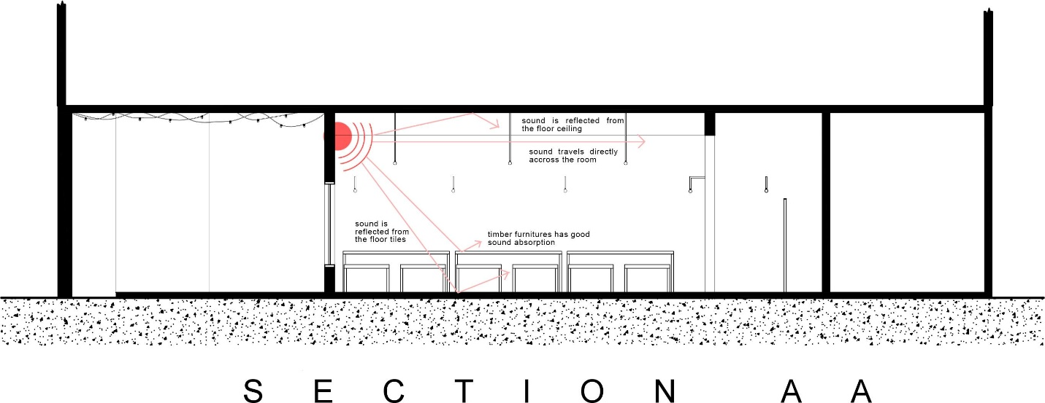

The café is also not equipped with materials of good sound absorption. The floor tiles are cemented and the ceiling causes high reflection of noise.
Although the furniture are made of timber, it is still not sufficient to reduce the amount of noise reflection. Carpet / timber flooring can be added to increase sound absorption.

    - Sound Reduction Index

ZONE A (COUNTER AREA)

Components | Materials | Colour | Surface  Finishes | Area(m2) | Sound Reduction Index
 |  |  |  |  | 500Hz | 2000Hz
Wall | Brick | White | Rough | 32.14 | 42.00 | 63.00
Door | Timber | White | Smooth | 1.89 | 20.00 | 22.00

Transmission Coefficient 500 Hz
SRI _{wall} = | 10log₁₀ |  |  |  | SRI _{Door =} |  | 10log₁₀
42= | 10log₁₀ 1 |  |  |  | 20= |  | 10log₁₀ 1
 | wall |  |  |  |  |  | door
4.2= | log 1 |  |  |  | 2.0= |  | log 1
 | wall |  |  |  |  |  | door
10 ^{4.2} = | 1 |  |  |  | 10 ² = |  | 1
 | wall |  |  |  |  |  | door
wall = | 6.309 x 10 ⁻⁵ |  |  |  | wall = |  | 1.0 x 10 ⁻²
Average Transmission Coefficient of Materials
T_{AV} = | ( T₁A₁) + (T₂A₂)
 | A₁+A₂
= | (6.309 x 10 ⁻⁵ x 32.14 ) + ( 1.0 x 10 ⁻² x 1.89 )
 |  |  | 32.14 + 1.89
= | ( 2.0277 x 10 ⁻³ ) + ( 0.0189 )
 | 34.03
= | 2.09277 x 10 ⁻²
 | 34
= | 6.14977 x 10 ⁻⁴
= | 6.15 x 10 ⁻⁴
SRI = | 10log₁₀ 1
 | T_{AV}
= | 10log₁₀ 1
 | 6.15 x 10 ⁻⁴
= | 32.11 dBs (2dp)
Transmission Coefficient 2000 Hz
SRI _{wall} = |  | 10log₁₀ |  |  |  | SRI _{Door =} |  | 10log₁₀
63= |  | 10log₁₀ 1 |  |  |  | 22= |  | 10log₁₀ 1
 |  | wall |  |  |  |  |  | door
6.3= |  | log 1 |  |  |  | 2.2= |  | log 1
 |  | wall |  |  |  |  |  | door
10 ^{6.3} = |  | 1 |  |  |  | 10 ^{2.2} = |  | 1
 |  | wall |  |  |  |  |  | door
wall = |  | 5.012 x 10 ⁻⁷ |  |  |  | wall = |  | 6.3095 x 10 ⁻³
Average Transmission Coefficient of Materials
T_{AV} = |  | ( T₁A₁) + (T₂A₂)
 |  | A₁+A₂
= |  | (5.012 x 10 ⁻⁷ x 32.14 ) + ( 6.3095 x 10 ⁻³ x 1.89 )
 |  |  |  | 32.14 + 1.89
= |  | ( 1.61085 x 10 ⁻⁵ ) + ( 0.011924955 )
 |  | 34.03
= |  | 0.011941063
 |  | 34.03
= |  | 3.50898 x 10 ⁻⁴
= |  | 3.51 x 10 ⁻⁴
SRI = |  | 10log₁₀ 1
 |  | T_{AV}
= |  | 10log₁₀ 1
 |  | 3.51 x 10 ⁻⁴
= |  | 34.55 dBs (2dp)

ZONE B (DINING AREA)

Components | Materials | Colour | Surface  Finishes | Area(m2) | Sound Reduction Index
 |  |  |  |  | 500Hz | 2000Hz
Wall | Brick | White | Smooth | 64.61 | 42.00 | 63.00
 | Glass | Clear | Smooth | 9.46 | 22.00 | 25.00
Door | Glass | Clear | Smooth | 1.89 | 18.00 | 20.00

Transmission Coefficient 500 Hz
SRI _{wall} = | 10log₁₀ |  | SRI _{Door =} | 10log₁₀
42= | 10log₁₀ 1 |  | 18= | 10log₁₀ 1
 | wall |  |  | door
4.2= | log 1 |  | 1.8 = | log 1
 | wall |  |  | door
10 ^{4.2} = | 1 |  | 10 ^{1.8} = | 1
 | wall |  |  | door
wall = | 6.309 x 10 ⁻⁵ |  | door = | 1.584 x 10 ⁻²
SRI _{wall} = | 10log₁₀
22= | 10log₁₀ 1
 | wall
2.2= | log 1
 | wall
10 ^{2.2} = | 1
 | wall
wall = | 6.3095 x 10 ⁻³
Average Transmission Coefficient of Materials
T_{AV} = | ( T₁A₁) + (T₂A₂) + (T₃A₃)
 | A₁+A₂ + A₃
= | (6.309 x 10 ⁻⁵ x 64.61 ) +(6.3095 x 10 ⁻³ x 9.46 ) + ( 1.58 x 10 ⁻² x 1.89 )
 |  | 64.61 + 9.46 + 1.89
= | (4.076x 10 ⁻³) +(5.9687 x 10 ⁻² ) + ( 2.99376 x 10 ⁻²)
 |  | 75.96
= | 0.0937006
 | 75.96
= | 1.23355 x 10 ⁻³
SRI = | 10log₁₀ 1
 | T_{AV}
= | 10log₁₀ 1
 | 1.23355 x 10 ⁻³
= | 29.09 dBs (2dp)

Transmission Coefficient 2000 Hz
SRI _{wall} = | 10log₁₀ |  | SRI _{Door =} | 10log₁₀
63= | 10log₁₀ 1 |  | 20= | 10log₁₀ 1
 | wall |  |  | door
6.3= | log 1 |  | 2.0= | log 1
 | wall |  |  | door
10 ^{6.3} = | 1 |  | 10 ² = | 1
 | wall |  |  | door
wall = | 5.012 x 10 ⁻⁷ |  | wall = | 0.01
SRI _{wall} = | 10log₁₀
25= | 10log₁₀ 1
 | wall
2.5= | log 1
 | wall
10 ^{2.5} = | 1
 | wall
wall = | 3.16227 x 10 ⁻³
Average Transmission Coefficient of Materials
T_{AV} = | ( T₁A₁) + (T₂A₂) + (T₃A₃)
 | A₁+A₂ + A₃
= | (5.012x 10 ⁻⁷ x 64.61 ) +(3.16227 x 10 ⁻³ x 9.46 ) + ( 0.01 x 1.89 )
 |  | 64.61 + 9.46 + 1.89
= | (3.23825x 10 ⁻⁵) +(0.029915 ) + ( 0.0189)
 |  | 75.96
= | 6.43067 x 10 ⁻⁴
= | 6.43 x 10 ⁻⁴
SRI = | 10log₁₀ 1
 | T_{AV}
= | 10log₁₀ 1
 | 6.43067 x 10 ⁻⁴
= | 31.92 dBs (2dp)

ZONE C (SMOKING AREA)

Components | Materials | Colour | Surface  Finishes | Area(m2) | Sound Reduction Index
 |  |  |  |  | 500Hz | 2000Hz
Wall | Brick | White | Smooth | 25.31 | 42.00 | 63.00
 | Glass | Clear | Smooth | 9.46 | 22.00 | 25.00
Door | Glass | Clear | Smooth | 1.89 | 18.00 | 20.00

Transmission Coefficient 500 Hz
SRI _{wall} = | 10log₁₀ |  | SRI _{Door =} | 10log₁₀
42= | 10log₁₀ 1 |  | 18= | 10log₁₀ 1
 | wall |  |  | door
4.2= | log 1 |  | 1.8 = | log 1
 | wall |  |  | door
10 ^{4.2} = | 1 |  | 10 ^{1.8} = | 1
 | wall |  |  | door
wall = | 6.309 x 10 ⁻⁵ |  | door = | 1.584 x 10 ⁻²
SRI _{wall} = | 10log₁₀
22= | 10log₁₀ 1
 | wall
2.2= | log 1
 | wall
10 ^{2.2} = | 1
 | wall
wall = | 6.3095 x 10 ⁻³
Average Transmission Coefficient of Materials
T_{AV} = | ( T₁A₁) + (T₂A₂) + (T₃A₃)
 | A₁+A₂ + A₃
= | (6.309 x 10 ⁻⁵ x 25.31 ) +(6.3095 x 10 ⁻³ x 9.46 ) + ( 1.58 x 10 ⁻² x 1.89 )
 |  | 25.31 + 9.46 + 1.89
= | (1.5968079x 10 ⁻³) +(5.9687 x 10 ⁻² ) + ( 2.99376 x 10 ⁻²)
 |  | 36.66
= | 2.488208999 x 10 ⁻³
= | 2.488 x 10 ⁻³
SRI = | 10log₁₀ 1
 | T_{AV}
= | 10log₁₀ 1
 | 2.488 x 10 ⁻³
= | 26.04 dBs (2dp)

Transmission Coefficient 2000 Hz
SRI _{wall} = | 10log₁₀ |  | SRI _{Door =} | 10log₁₀
63= | 10log₁₀ 1 |  | 20= | 10log₁₀ 1
 | wall |  |  | door
6.3= | log 1 |  | 2.0= | log 1
 | wall |  |  | door
10 ^{6.3} = | 1 |  | 10 ² = | 1
 | wall |  |  | door
wall = | 5.012 x 10 ⁻⁷ |  | wall = | 0.01
SRI _{wall} = | 10log₁₀
25= | 10log₁₀ 1
 | wall
2.5= | log 1
 | wall
10 ^{2.5} = | 1
 | wall
wall = | 3.16227 x 10 ⁻³
Average Transmission Coefficient of Materials
T_{AV} = | ( T₁A₁) + (T₂A₂) + (T₃A₃)
 | A₁+A₂ + A₃
= | (5.012x 10 ⁻⁷ x 25.31 ) +(3.16227 x 10 ⁻³ x 9.46 ) + ( 0.01 x 1.89 )
 |  | 25.31 + 9.46 + 1.89
= | (1.26853x 10 ⁻⁵) +(0.029915 ) + ( 0.0189)
 |  | 36.66
= | 0.048062685
 | 36.66
= | 1.311 x 10 ⁻³
SRI = | 10log₁₀ 1
 | T_{AV}
= | 10log₁₀ 1
 | 1.311 x 10 ⁻³
= | 28.82 dBs (2dp)

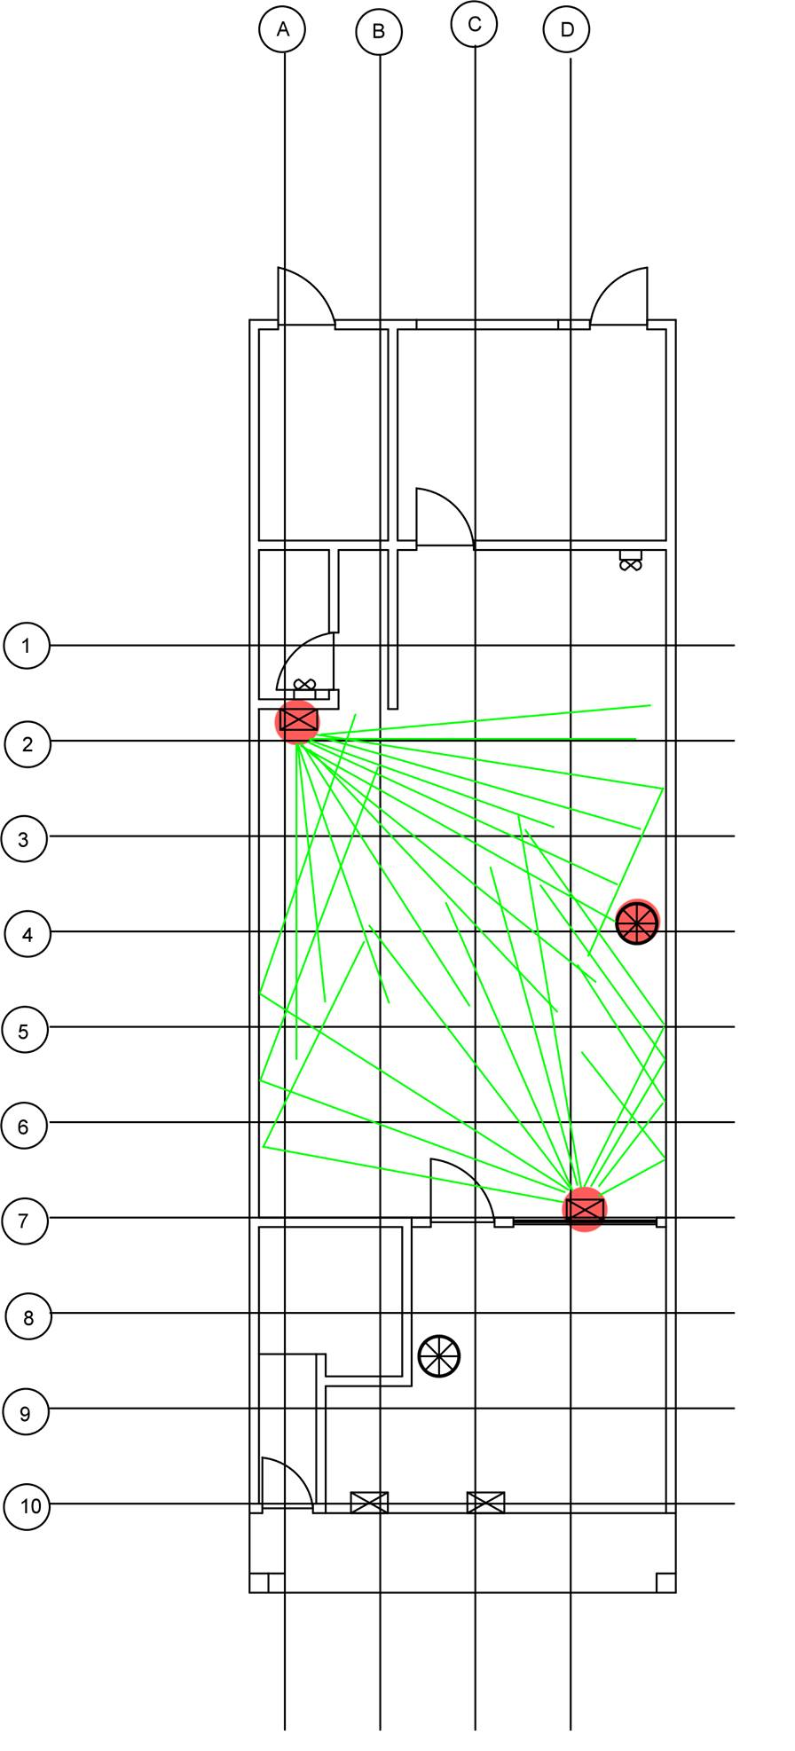
Reflective Ray Diagram

ZONE A & B

Figure 3.7.3.1 : Reflective ray diagram at zone A & B

The diagram shows the reflective rays originating from the noise source, which is the speaker and the fan. The red dot indicates the exact position of the speakers and the fan. As it is positioned at both ends of the café, the rays indicate that there is a relatively even distribution of noise throughout the space. The noise coming from the fan is not prominent as it is overpowered by the speakers.

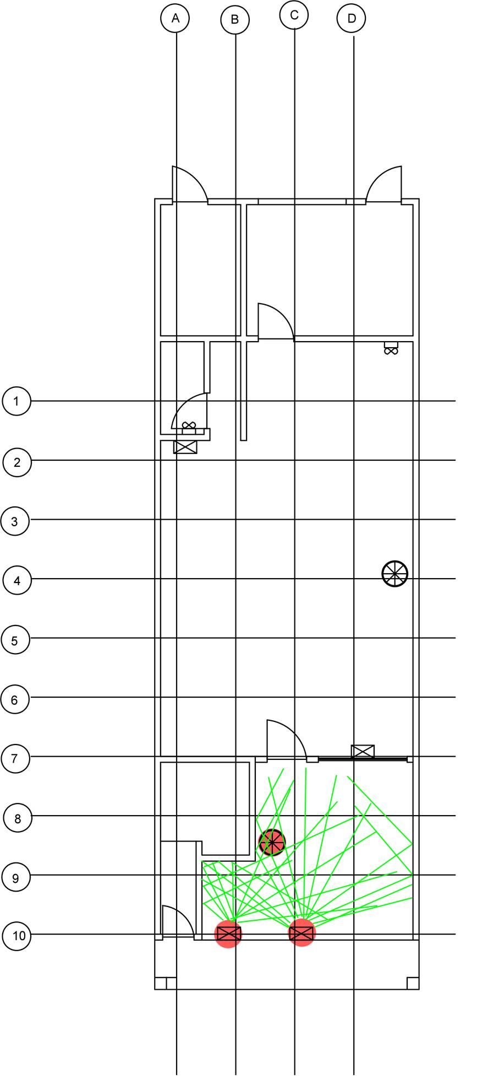
ZONE C

Figure 3.7.3.2 : Reflective ray diagram at zone C

The diagram shows the reflective rays originating from the noise source, which is the speakers and fan. The red dot indicates the exact position of the appliances. The speakers are positioned within close proximity of one another, thus creating a greater reflection of sound at the bottom corner of the area. The area affected will become a lot louder in comparison to the top right of the area. Noises coming from external sources will also affect the area.

3.8 Conclusion

Based on the analysis conducted, it can be said that the noise level of the café is evenly distributed through all three zones. First and foremost, this is mainly due to the special layout of the café. Minimum partitions and open floor plan allows sound to travel freely within the space, with minimum restrictions. Besides that, the small area of the space affects the amount of noise that travels within the space. The high number of occupants and the high use of appliances contributes to the relatively loud area. The position of appliances within the space allows an even distribution of noise throughout the café. Speakers are placed around the area so music travels thoroughly.

However, one of the issues in relation to acoustics is its short reverberation time. The café uses materials of low absorption that causes noise to bounce back within the space. The close position of the furniture makes matters even worse, as there are very little quiet spots in the café.

The café may take into consideration of replacing some of its materials into that of higher absorption rate in order to reduce reflection of noise. Besides that, spacing out the furniture may also help in reducing the amount of noise in the area.

4.0
REFERENCES

- Duran, S. (2015, August 13). Daylight Sunlight and Overshadowing Assesment. Retrieved November 2, 2016, from http://www6.kingston.gov.uk/

- Hunt, D. R. G. (1979). The use of artificial lighting in relation to daylight levels and occupancy. Building and environment, 14(1), 21-33.

- Li, D. H., & Lam, J. C. (2001). Evaluation of lighting performance in office buildings with daylighting controls. Energy and Buildings, 33(8), 793-803.

- Muneer, T., & Kubie, J. (2000). Windows in buildings: thermal, acoustic, visual and solar performance. Architectural Press.

- Lee, Y. S. (2010). Office layout affecting privacy, interaction, and acoustic quality in LEED-certified buildings. Building and Environment, 45(7), 1594-1600.

- Ingård, U., & Bolt, R. H. (1951). Absorption characteristics of acoustic material with perforated facings. The Journal of the Acoustical Society of America, 23(5), 533-540.

- Jacobsen, F. (2003). Sound intensity and its measurement and applications. Current Topics in Acoustical Research, 3, 87-91.

