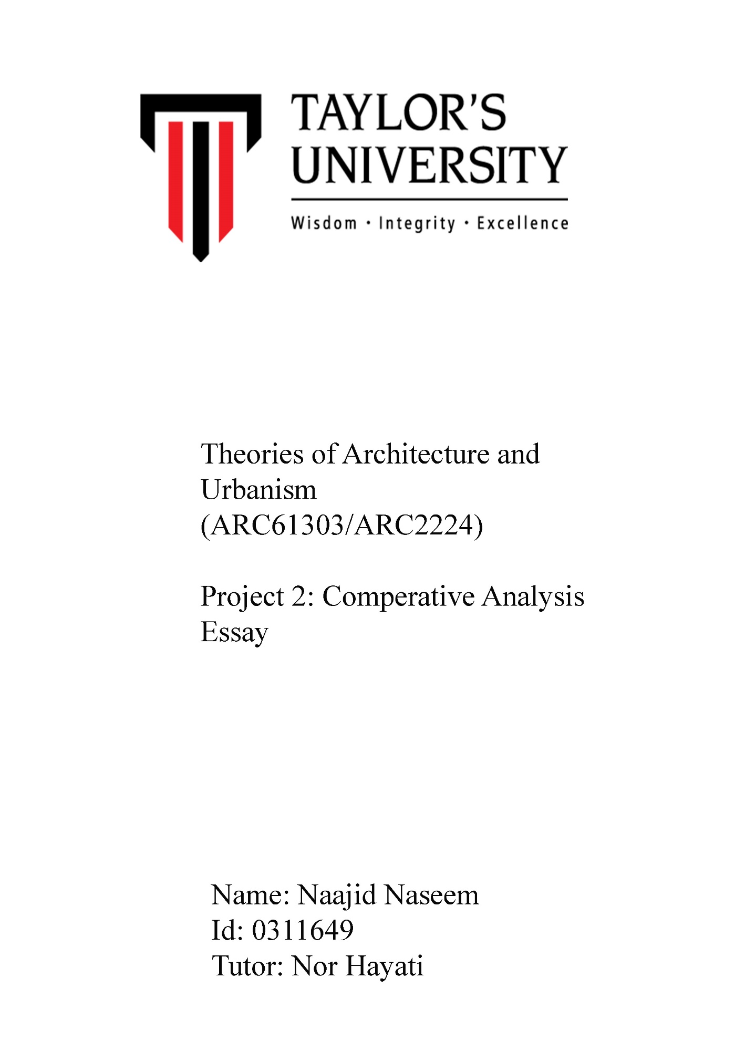1.0 INTRODUCTION

*South of Market, San Francisco*The chosen area for the site study (project 1) was the South of Market Street, San Francisco, United States. This area was a getaway from the most of the rest of San Francisco due to the great density of commercial blocks around the area. South of Market, San Francisco and area has a grid typology made up of commercial blocks, institutions and residential areas.

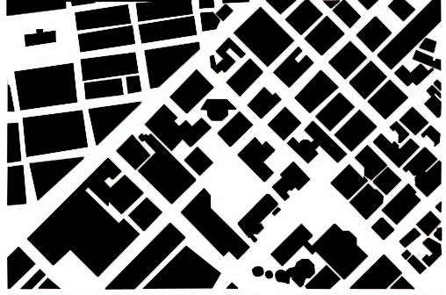

Figure 1.0 grid typology

*Petaling Street, Kuala Lampur*

The chosen area for the local site research (studio) was in the city center, Kuala Lampur focusing on the area within jalan Petaling. Similar to South of Market, San Francisco this neighborhood is also dominated by mostly commercial buildings. It is observed that most of the commercial buildings are ‘shophouses’ in Kuala Lampur. However, unlike south of Market, the area around jalan Petaling has an observable deformed typology

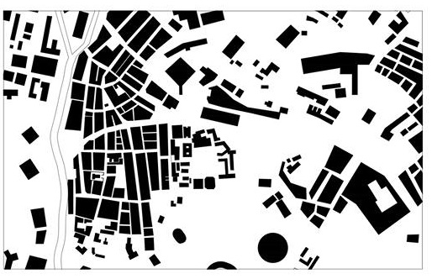

Figure 1.1 deformed typology

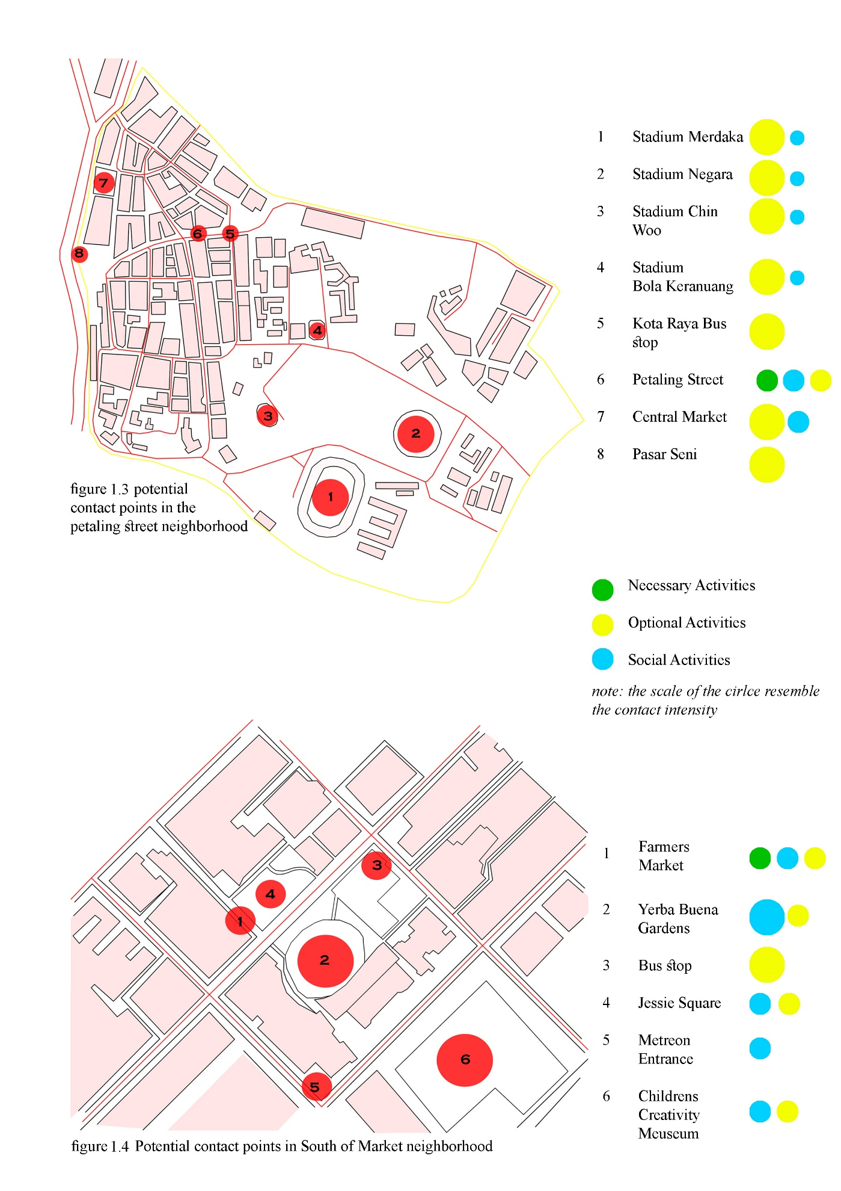

2.0 COMPARISON

*Necessary Activity*

Despite the differences in the typology of the two neighborhoods, they have similarities in terms of the necessary activities that take place within the area. Necessary activities are compulsory activities that are needed to be accomplished despite the exterior factors (Gehl & Koch, 2003). To start with, both neighborhoods consist of transportation hubs where most of the necessary activities take place. The bus stop in San Francisco and the Kota Raya bus stop in Kuala Lampur can be taken as an example. These are contact points in which necessary activity takes place because they are being used as a mode of transportation which is a necessity in order to travel from one place to another. One of the similarities in both of the bus stop is the presence of commercial and institutional buildings around the area which in turn results in more people occupying the areas. Furthermore, the fact that both of the bus stops are in the intersection point of the roads is also a striking similarity and this also raises the contact intensity within the areas. However it is noticed that the Moma bus stop has more vegetation around the area which creates a more friendly atmosphere as compared to the Kota Raya bus stop. According to Farr (2008), “People are three times more likely to walk along landscaped pedestrian routes. Mature tree cover can further encourage daily outdoor activity by cooling outdoor summer temperatures between five and ten degrees Fahrenheit” (p.49).

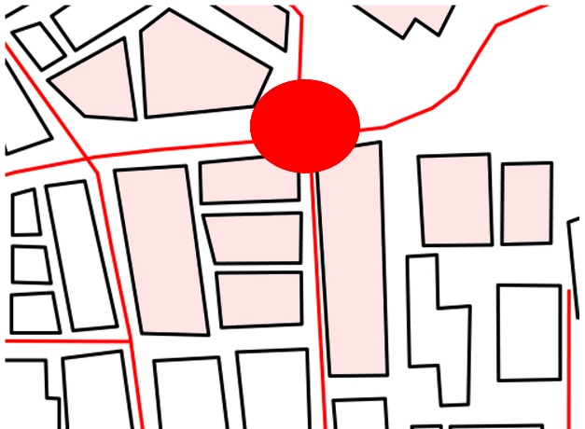 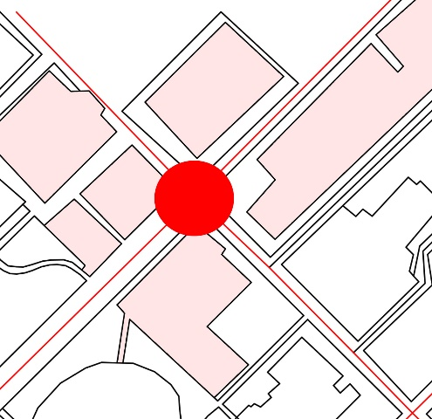

Figure 2.1 Kota Raya bus stop and the presence Figur 2.2 Moma bus stop and   
of buildings presence of buildings

*Optional and Social Activity*

Despite the similarities, there are considerable differences found between the contact points in which social activities take place. These social activities take place only when time and exterior conditions permits the user. Gehl & Koch (2003) defines optional activity as “those pursuits that are participated if there is a wish to do so and if time and place make it possible” (p.11). To start with, I feel that neighborhood of petaling street lacks public spaces such as public parks in comparision to the neighborhood in San Francisco. As a result the contact points in Kuala Lampur are observed to have less people engaging in social activities as compared to San Francisco. For example, Yerba buena garden and jessie Square in San Francisco are public spaces specially designed for the interaction between the ‘passive contacts’. On the other hand, neighborhood in Petaling Street lack public spaces which are specifically designed to engage the user in social or optional activity.

There are also similarities in terms of optional and social activities that takes place in the contact points of the two neighborhoods. For instance, farmer’s market in San Francisco and Petaling Street in Kuala Lampur are contact points where people are engaged in optional activites. There are various similarities in the type of activity that people take place in the two contact points. I greatly feel that this is due to the similar use of features in the contact points. For instance, both Farmers market and Petaling street have certain features such as existence of walk in restaurants, pockets of spaces in between buildings and food stalls which encourages human activity and interaction. City of Melbourne (2006), claims that kerbside café are one of the prominent urban elements in Melbourne as they contribute value to cultural idendity, economic prosperity, sustainability and to public lives

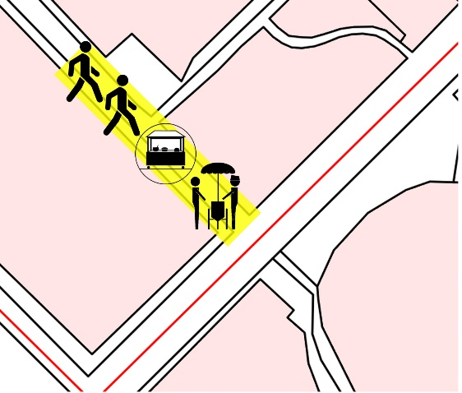 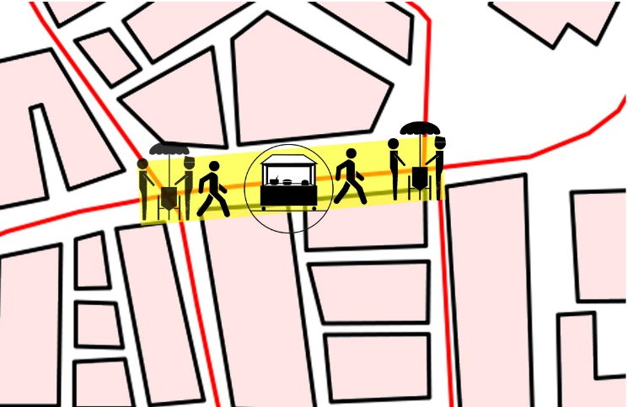

Figure 2.3 activity at farmer’s market figure 2.4 activity at petaling street

Other contact points where optional and social activities take place include Jessie square in south of market and central market in Kuala lampur. These contact points are similar because they consist of public areas dedicated for public interaction. For example Jessie square in San Fransisco is an area with street furniture which allows the users to stop and engage in some type of activity and has a grass land allocated for dog walking. Similarly central market in Kuala Lampur also has an open area at the back of the building which is allocated social activities to take place. Haas (2012) claims that such open spaces can provide a number of ecological benefits and visual relief.

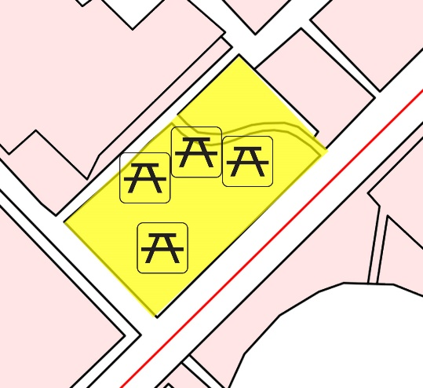 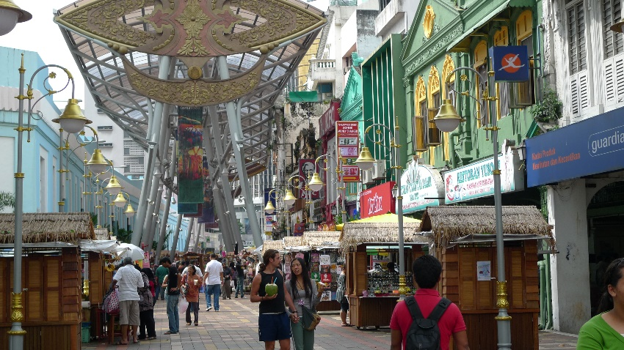

Figure 2.5 street furniture jessie square Figure 2.6 Outdoor space in Central Market

One of the the differences between the social activities that take place in the two neighborhoods are the features used to maximize the user sensory experience of the space. For instance, Yerba buena garden and several other public spaces in San Francisco offers water features which consequently maximizes the user sensory experience of the space. This is a feature seen on many of the public spaces and parks around the world which draws more people to wait and admire the view. Eventually this causes people to engage in some social activity. However, the neighborhood Petaling Street offers an alternative feature that maximizes the user sensory experience of the space. This is the use of five foot way in Jalan Tun H.S Lee which creates a more intimate connection between the road users and pedestrians. It also makes the verticality vs horizontality movement more apparent and creates feasible interaction on the streets and shophouses.

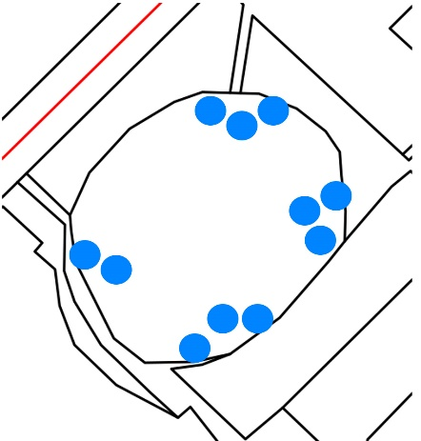 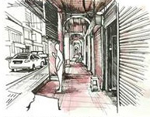

Figure 2.6 use of water feature Figure 2.7 use of five foot way

at Yerba Buena garden

*Varying degree of Contact Points*

Taking the above mentioned points into consideration, I feel that it is safe to assume that there are different types of contact points in the two neighborhoods in which different social activities take place. But these contact points do not produce the same degree of contact intensity within human interaction. For example churches and stadiums can produce a high contact intensity as compared to public park. Meaning that, a person is more likely to meet a family member or friend in a neaby church. Hence, providing a possibility to improve a relation with an emotionally involved family member. According to Gehl & Koch (2003) people are more likely to have more comprehensive conversations, greetings and discussions because of the fact that they know each other or because they often see each other. It is important to note that both the Petaling Street neighborhood and San francisco neighborhood has an acceptable amount of religious buildings in which these higher contact intensity take place.

On the other hand lower intensity interaction occurs in places where people are able to merely see, meet and hear others. Such interaction takes place usually in public spaces, parks and streets with walk in café’s and etc. Especially in places where people are more subjected to meet simple non commital contacts. According to Gehl & Koch (2003) these type of contact forms are more valuable and independent contact forms as they allow more complex interactions. There numerous places in the neighborhood of San Francisco where lower intensity contact interaction (passive contacts) take place. For example, Farmers garden, Jessie Square, Bus stop, Metreon entrance and Yerba buena garden are places in which the possibility of meeting new acquaintances are high. Street furniture’s, water features and the excellent road conditions helps the people to engage in different social activities in which people are able to just ‘see and hear’ others. Similarly, Petaling Street, central market, and transportation hubs around the neighborhood in Kuala Lampur are also places in which lower intensity interaction takes place. The different types of shop stalls and restaurants in Petaling street and the busy streets nearby the transportation hubs creates a medium for people to meet in an unpredictable, spontaneous and unplanned way. In addition to this, the pockets of spaces in Kuala Lampur neighborhood is also a potential contact point for lower intensity interaction because I feel that it provides sufficient shade from the high rise buildings which is essential in a hot tropical climate.

3.0 CONCLUSION

In order to have a friendly, safe neighborhood one crucial factor is to establish a well maintained relationships among people in neighborhood. According to Haas (2012), a sustainable and a healthy city needs more walkable and less driving neighborhoods, with less air pollution and less obesity. To do this, public spaces where people can interact are important as these places help people to maintain already established contacts in the neighborhood. Furthermore this is also a potential opportunity to create new acquaintances and meet new people. In a nutshell, it is fair to conclude that both Petaling street neighborhood and South of market in San Francisco has several similarities and differences in terms of the social activities that takes place within the contact points. I feel that Petaling street neighborhood can introduce more features and places that would allow more people to engage in public activities. For instance, introduction of more public parks would be an ideally good start. Another feature that could possibly drive people to wait and engage in activities is the use of street furniture’s in Petaling street neighborhood. Hence, this becomes a space where the possibility of meeting new people are high. In addition to this, introducing features such as water features in already existing public spaces in Kuala Lampur would also increase the social and optional activities. In conclusion, I strongly believe that introducing the above mentioned features such as street furniture to the pockets of spaces in between the buildings in Kuala Lampur would improve the relationships between the citizens of the neighborhood in Kuala Lampur.

References

Gehl, J., & Koch, J. (2003). *Life between buildings: Using public space* (5th ed.). Copenhagen: The Danish Architectural Press

Haas, T. (2012). Sustainable Urbanism and Beyond: Rethinking Cities for The Future. Rizzoli International Publications, Inc. (1st ed.). New York, NY.

Towards a Better ‘Public Melbourne’: Draft Urban Design Strategy. (2006). Melbourne City Council.Melbourne, VIC: City of Melbourne.

Farr, D. (2008). Sustainable Urbanism: Urban Design with Nature. John Wiley & Sons, Inc. Hoboken, New Jersey.